A Report on

Generative AI with AWS

At RemoteBase X Scale AI

SUBMITTED IN PARTIAL FULFILLMENT FOR AWARD DEGREE OF

BACHELOR OF ENGINEERING

IN

Computer Science and Engineering

BY Ankit Rout

SG20363



DEPARTMENT OF Computer Science and Engineering UIET, PANJAB UNIVERSITY SSG REGIONAL CENTRE, HOSHIARPUR-146021, Punjab (INDIA) 2024

# DECLARATION

I hereby declare that I have completed my Semester long training at **Remotebase** from **8/01/2024** to **25/05/2024** under the guidance of **Maleeha Anwar**. I have declared that I have worked with full dedication during one month of training and my learning outcomes fulfil the requirements of training for the award of degree of Bachelor of Engineering in Computer Science Engineering, University Institute of Engineering & Technology Panjab University Swami Sarvanand Giri Regional Center, Hoshiarpur.

Name: **Ankit Rout**

Roll Number: **SG2036****3**

# Acknowledgement

I want to express a deep sense of Gratitude all those people who have supported me to accomplish my job training project. First, I would like to thank the management of **PUSSGRC, Hoshiarpur** who has given me the opportunity to accomplish my training for partial fulfillment of the requirement for the degree of B.E.to **Panjab University**.

**I am thankful to Remotebase for providing me the relevant training and certification.**

# ABSTRACT

This training program encompasses four fundamental areas crucial to understanding and implementing artificial intelligence (AI) in contemporary contexts:

1. **Artificial Intelligence in Context:** Delve into the historical evolution of AI and its pervasive integration across diverse industries. Critically analyze its societal impact and transformative potential.
2. **Foundations of Artificial Intelligence and Machine Learning:** Explore the intricate relationship between AI and machine learning (ML), covering various ML methodologies and their practical applications. Gain insights into innovative AI models shaping the technological landscape.
3. **Understanding Large Language Models (LLMs):** Take a deep dive into the architectures of Large Language Models, focusing on transformer-based models, prompt engineering techniques, and fine-tuning mechanisms.
4. **Real-world Applications of Generative AI:** Investigate the tangible societal implications of generative AI and its transformative potential. Emphasize the importance of responsible and inclusive deployment in addressing ethical, societal, and economic concerns.

Upon completion of this training, participants will be equipped to:

* Provide a comprehensive overview of AI's historical and societal context.
* Differentiate between primary ML types and distinguish AI from ML.
* Understand Large Language Models, particularly transformer-based architectures.
* Evaluate the ethical, societal, and economic implications of generative AI, advocating for responsible deployment.

This immersive learning experience combines AI-driven case studies with hands-on coding exercises, culminating in a capstone project to showcase acquired skills and knowledge.

# Remotebase X Scale AI : Onboarding

Hello Ankit,

Scale Ai has sent you a link to set up your profile please use  the link **.** As mentioned earlier please ensure you log in using your Remotebase email ID.

**This is a unique link - please do not share this link with anyone else. This is tracked based on your remotebase email ID and location. If any link is shared or accessed using a different email ID or location, this will be immediately flagged and you will be removed from the process.**

Once you log in, you need to go to your account settings and update the following information prior to starting your onboarding process.

Please add the following informationexactly as presented below so that Scale Ai can cross check the data we have shared with them. If you modify any of the information below they may block your account.

Account Page:

**First Name: Ankit**

**Last Name: Rout**

**Back Up Email ID:** ankit.rout@remotebase.com

Profile Page:  
**Country Location: India**

**It is extremely important that you only log in to this site whilst in your home country, do not use a VPN while accessing this site as your location will be flagged and blocked by Scale Ai fraud team.**

Scale Ai has created a step by step guide for you on how to navigate, it is important to go through to understand the process in detail.

If you face any technical issues with the platform please reach out to us on the **Remotebase Slack Channel** for further assistance and one of our team will support you within working hours **(IST Timezone: Monday - Friday 9am to 6pm).**

Good luck with the final step in your process!

Regards,

**Maleeha Anwer**

**Talent Success Manager**

Talent Success

Santa Carla ,California, USA

**[](https://remotebase.com/)  [](https://maps.app.goo.gl/iqCooTgswxrH2BJB6)**  **[](http://www.linkedin.com/company/remotebasehq)  [](http://www.notion.so/remotebasehq)  [](http://www.twitter.com/remotebasehq)**

****

# Introduction to AI

**Artificial Intelligence (AI)** refers to computers simulating human intelligence processes like learning, reasoning, self-correction, and creativity.

### **Historical Development**

AI exploration began in the **1940s and 1950s**, inspired by the human brain's workings. Notable contributions include:

## **Artificial Intelligence (AI) and Its Subfield**

* **AI** is about simulating human-like reasoning in computers to perform tasks requiring intelligence, such as recognizing patterns, making decisions, and predictions.
* **Machine Learning (ML)**, a subset of AI, involves machines learning from data to improve at tasks over time. It employs **algorithms** to find patterns or regularities in data.
* **Models** in ML are the specific mathematical structures or computational systems that learn from data to make predictions or decisions.
* **Deep Learning**, a further subset of ML, utilizes **neural networks** (inspired by the human brain's structure and function) to analyze various factors of data.
* **AI Ethics** is crucial to ensure fairness, unbiased nature, and respect for human rights, addressing concerns on data sources and what AI learns from it.
* The **Turing Test**, by Alan Turing, used to determine a machine's capability to exhibit intelligent behavior.
* **ELIZA,** the first AI chatbot created in the **1960s.**

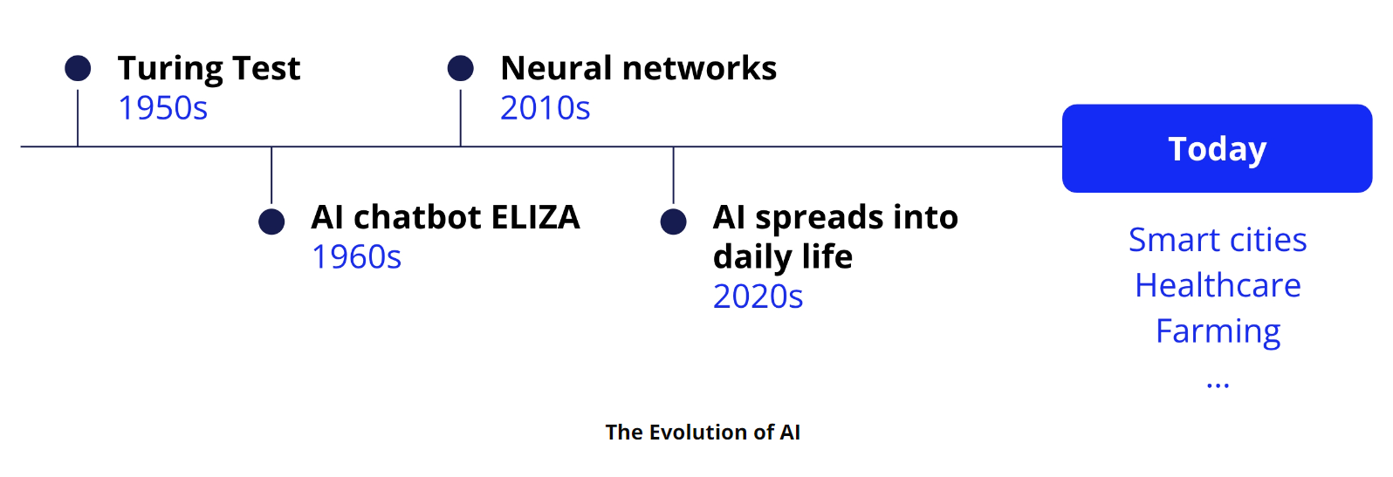

### **Acceleration in AI Advancements**

The onset of the **internet and vast data availability** propelled **Machine Learning (ML)**, a subset of AI, allowing machines to learn and improve from vast data sets.

In the **2010s**, **Deep Learning**, inspired by human brain's neural networks, emerged, aiding in **object and voice recognition**.

### **AI in Everyday Life**

AI's role has transitioned from mere fascination to being an integral part of daily lives, aiding in image enhancement, spam filtering, traffic management, healthcare diagnostics, and agricultural optimization, among others.

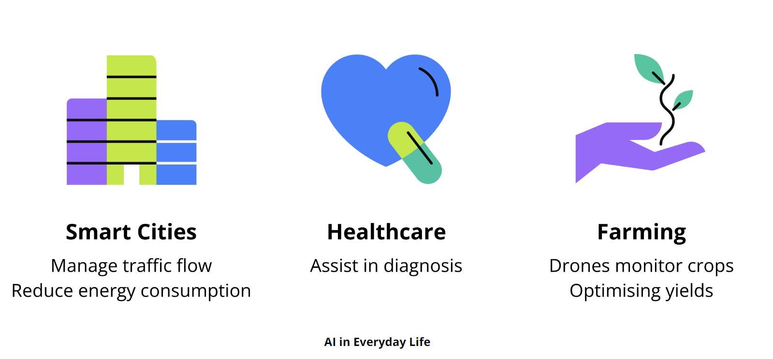

# ELIZA Chatbot

## **Meet My Therapist- ELIZA**

ELIZA, a computer program created in the 1960s, was one of the first programs designed to have a conversation with people.

ELIZA would respond to what you said by using patterns and rules, making it seem like she understood you. One famous version of ELIZA acted like a therapist, where she'd often just repeat what you said back to you, which made some people feel like they were talking to a real person.

We demonstrate ELIZA in the demo below.

## **Exercise: Simulating a Conversation with ELIZA**

In this exercise, you'll chat with ELIZA and observe how it uses pattern matching and rules to respond to you. Then you'll try to figure out the "rules" ELIZA follows by providing specific inputs and analyzing the outputs.

Use the following link to experiment with an [**ELIZA-like Therapist Bot(opens in a new tab)**](https://anthay.github.io/eliza.html), provided by Ant & Max Hay.

* **Pattern Matching** is like a game of recognizing words or phrases and linking them to responses.
* **Rules-based Systems** are a set of instructions that tell ELIZA what to say when it recognizes certain patterns.

### **Step 1 - Meet ELIZA**

* Go to the [**link(opens in a new tab)**](https://web.njit.edu/~ronkowit/eliza.html) for an ELIZA simulation.
* Begin the conversation with a simple greeting like "Hello, ELIZA."

### **Step 2 - Chat and Observe**

* Continue the conversation with ELIZA using various phrases:
  + Share a feeling: "I feel happy today."
  + Ask a question: "What should I do now?"
  + Make a statement: "I am worried about my exams."
* Note how ELIZA responds to each type of input.

### **Step 3 - Detect Patterns**

* Look at ELIZA's responses and think about why it might have said what it did.
* Try to identify keywords in your input that ELIZA might be responding to.

# Defining Artificial Intelligence

## **Defining Artificial Intelligence (AI)**

**Artificial Intelligence (AI)** involves simulating human-like reasoning and cognitive processes in computers, aimed at creating systems capable of performing tasks requiring intelligence when done by humans. These tasks include:

* **Recognizing patterns.**
* **Speech recognition.**
* **Decision-making.**
* **Making predictions**.

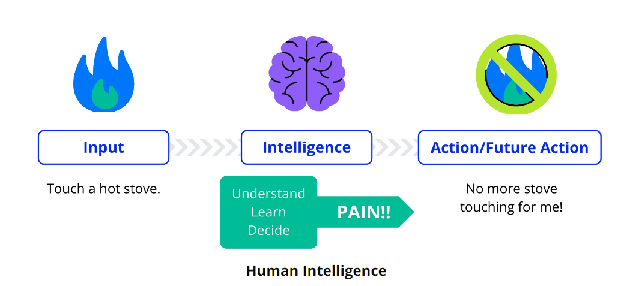

**Human intelligence** processes information, learns from it, and informs future actions based on the learned information, e.g., learning not to touch a hot stove after experiencing a burn.

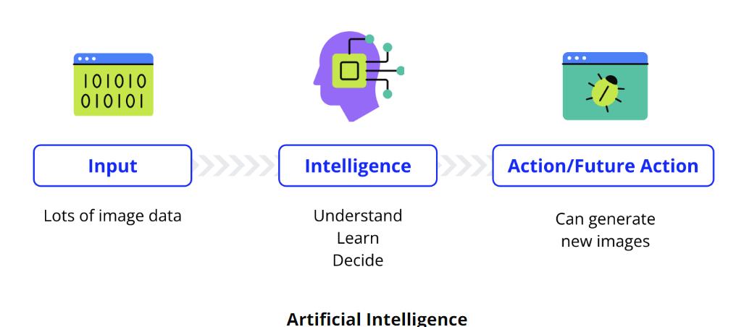

In AI, the goal is to replicate human learning and decision-making processes by creating sophisticated computer programs that can:

* **Process vast data.**
* **Learn patterns.**
* **Make informed decisions.**

A practical example includes streaming platforms using AI to analyze user preferences, compare them with other users, and recommend shows or music, improving recommendations as more data (user interaction) is collected.

# Artificial Intelligence in Society

## **Everyday Applications of AI**

**Artificial Intelligence (AI)** is subtly integrated into our daily lives, making tasks simpler, more efficient, and personalized. It's often unnoticed, termed as "silent" AI. Examples include:

* **Auto-tagging** in social media.
* **Fraud detection** in banking.
* **Recommendation systems** in music playlists or online shopping.
* **Smart thermostats** adjusting temperatures.
* **Ride-sharing apps** optimizing routes and prices.
* **Wearable devices** monitoring health metrics.

### **Responsible Use and AI Ethics**

As AI aims to learn like humans, attention must be paid to **AI Ethics**, which include:

1. What computers learn, and
2. How they learn it.

Ensuring AI is fair, unbiased, and respects human rights, equity, and privacy is crucial for societal benefit.

# **Introduction to Amazon SageMaker**

Amazon SageMaker is a cloud platform that helps users easily build, train, and deploy machine learning models. It's great for beginners and experts alike, simplifying complex tasks that usually require deep machine learning knowledge.

In the video above, we created a very simple chatbot with an interactive loop that:

* Continuously accepts input from the user.
* Processes the input.
* Responds until the user decides to end the conversation by typing "quit".

### **Create A Chatbot in 3 Steps**

#### Defining the Responses Dictionary

1. responses = {
2. "hi": "Hello there! How can I assist you today?",
3. "how are you": "I'm a bot, so I don't have feelings, but I'm functioning properly!",
4. "bye": "Goodbye! Have a great day!",
5. "help": "Sure, I can help you. What do you need assistance with?",
6. }

* responses is a Python dictionary that acts as a simple database for the chatbot. Each key is a possible message that the chatbot can recognize (e.g., "hi", "how are you"), and each value is the chatbot's predefined response to that message.

#### Defining the Function to Get Bot Responses

*def* get\_bot\_response(*user\_input*):

user\_input = user\_input.lower()

return responses.get(user\_input, "I'm not sure how to respond to that. Can you try asking something else?")

* def get\_bot\_response(user\_input): defines a function in Python called get\_bot\_response, which will process the user's input.
* user\_input = user\_input.lower() takes the user's input and converts it to lowercase. This is done so the chatbot can match the input to the keys in the responses dictionary without being case-sensitive.
* return responses.get(user\_input, "I'm not sure how to respond to that. Can you try asking something else?") uses the .get() method to look for the user\_input in the responses dictionary. If user\_input is found, it returns the associated response. If it's not found, it returns a default message: "I'm not sure how to respond to that. Can you try asking something else?"

#### Running the Main Chat Loop

1. while True:
2. user\_input = input("You: ")
3. if user\_input.lower() == "quit":
4. print("Bot: Goodbye!")
5. break
6. response = get\_bot\_response(user\_input)
7. print(*f*"Bot: {response}")

* while True: starts an infinite loop. This allows the chatbot to continue running and responding to user input until it's explicitly told to stop.
* user\_input = input("You: ") displays "You: " to the user and waits for them to enter their message. This message is stored in the variable user\_input.
* if user\_input.lower() == "quit": checks if the user has typed "quit" (case-insensitive) as their message.
* print("Bot: Goodbye!") sends a farewell message to the user if they've decided to quit.
* break exits the while loop, effectively ending the chatbot session.
* response = get\_bot\_response(user\_input) calls the get\_bot\_response function with the user's input to get the appropriate response from the chatbot.
* print(f"Bot: {response}") prints out the chatbot's response to the console.

# Introduction to SageMaker

## **Create A Tech Gadget Customer Support Chatbot**

Imagine you own an online store that sells various tech gadgets. You often receive common questions regarding product specifications, return policies, shipping methods, and technical troubleshooting. To streamline customer support and provide immediate assistance, you decide to implement a simple chatbot.

In this exercise you will use Amazon SageMaker to create a chatbot that can respond to customer inquiries about:

* **Product Information** (e.g., "Tell me about product X", "Do you have smartwatches?")
* **Shipping Details** (e.g., "How long does shipping take?", "What shipping methods are available?")
* **Return Policy** (e.g., "What is your return policy?", "How do I return a product?")
* **Technical Support** (e.g., "My gadget won’t turn on", "How do I reset my device?")

### **What Your Chatbot Can Do**

The chatbot should be able to:

1. Greet the user.
2. Understand and respond to specific questions about products, shipping, returns, and support.
3. Provide a default response for unrecognized queries.
4. Politely end the conversation.

### **Step 1: Setup SageMaker**

1. Click **Launch Cloud Gateway** in the bottom left corner of the classroom menu.
2. Click **Open Cloud Console.**
3. In the search bar in the to left side of the screen type, "**sagemaker**" and click on **Amazon SageMaker.**
4. From the SageMaker main page create a **Notebook** instance. Name your notebook but retain all default values. You will need to create a new IAM role during the setup.

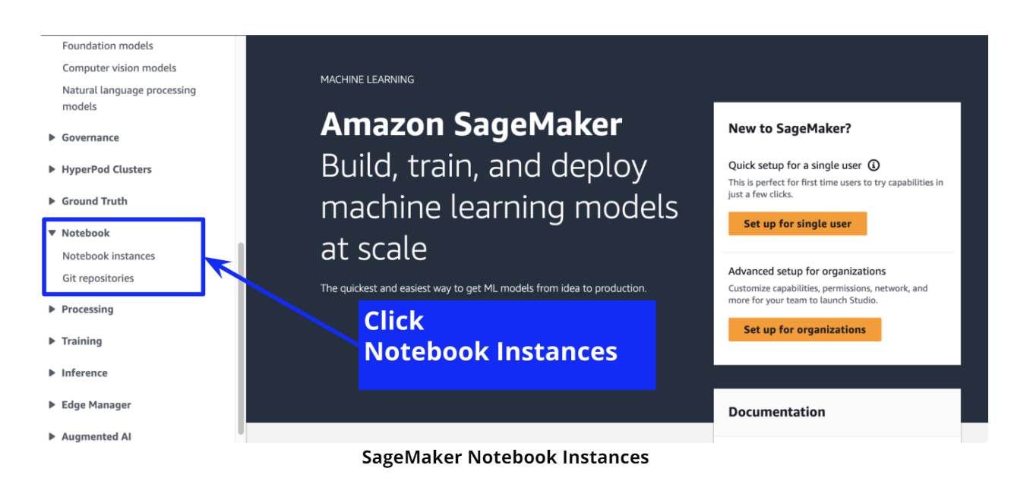

1. Once in the Notebooks dashboard, click **Create notebook instance** to start a Jupyter Notebook environment.

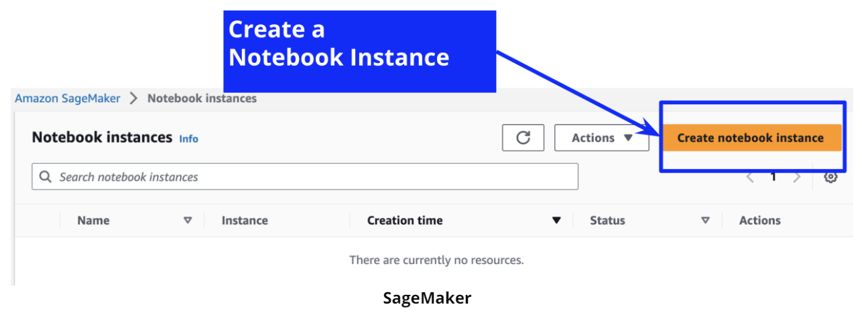

1. In the Notebook instance settings you will:
   * enter a name for your notebook instance
   * create an IAM role for your instance (use the default in the wizard)
   * leave all other items in their default setting

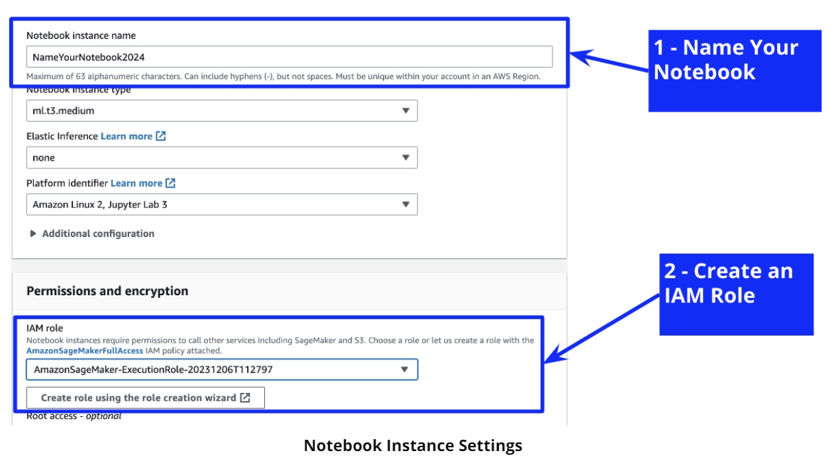

1. Open the notebook once the status is **InService**.

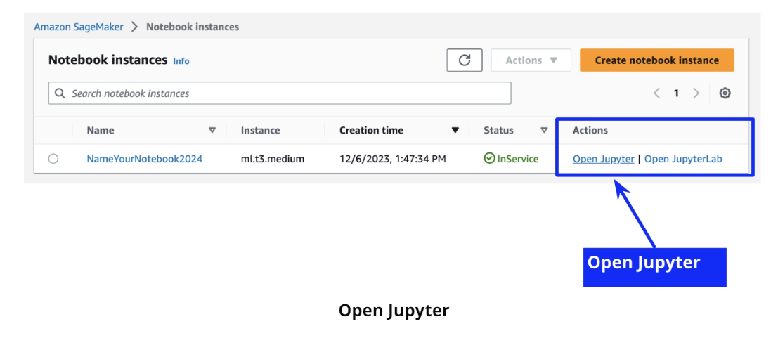

1. In the notebook click **New** and select the notebook type **conda\_python3**.

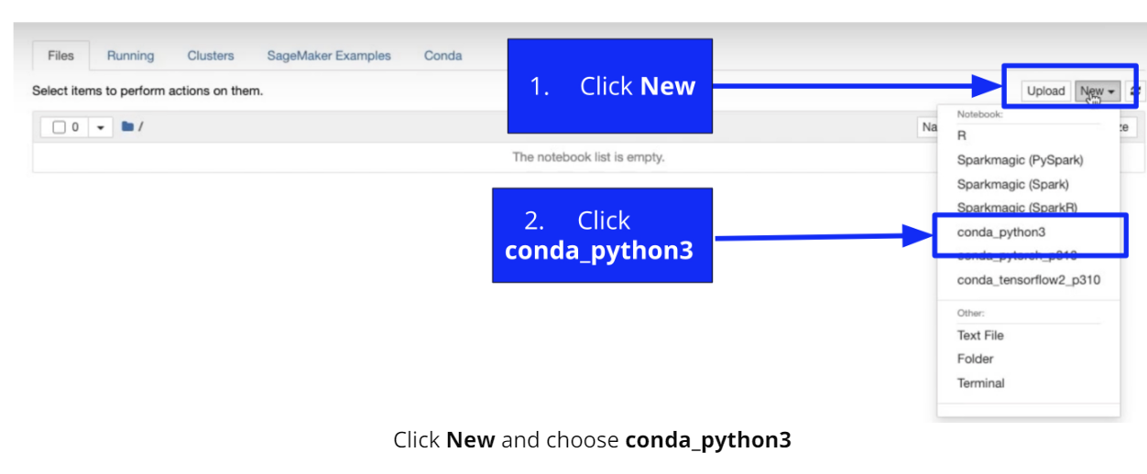

Click **New** and choose **conda\_python3**

1. Paste the following chatbot code in the first notebook cell and interact with the chatbot.
2. # Simple Customer Support Chatbot
3. responses = {
4. "hi": "Hello! Welcome to TechGadget Support. How can I assist you today?",
5. "do you have smartwatches": "Yes, we have a variety of smartwatches. You can check them out on our products page.",
6. "shipping time": "Shipping usually takes 3-5 business days.",
7. "shipping methods": "We offer standard, expedited, and overnight shipping.",
8. "return policy": "You can return products within 30 days of receipt for a full refund.",
9. "how to return": "To return a product, please visit our returns page for a step-by-step guide.",
10. "won’t turn on": "Make sure your gadget is charged. If it still won’t turn on, you can visit our troubleshooting page.",
11. "reset device": "To reset your device, hold down the power button for 10 seconds. If that doesn't work, please check the manual for a factory reset.",
12. "bye": "Thank you for visiting TechGadget. If you have more questions, feel free to ask. Goodbye!"
13. }
14. *def* get\_bot\_response(*user\_input*):
15. *user\_input* = *user\_input*.lower()
16. for keyword, response in responses.items():
17. if keyword in *user\_input*:
18. return response
19. return "I'm not sure how to respond to that. Can you try asking something else?"
20. while True:
21. user\_input = input("You: ")
22. if user\_input.lower() in ["quit", "exit", "bye"]:
23. print("Bot: Goodbye! If you have any more questions, we're here to help.")
24. break
25. response = get\_bot\_response(user\_input)
26. print(*f*"Bot: {response}")
27. # Simple Customer Support Chatbot
28. responses = {
29. "hi": "Hello! Welcome to TechGadget Support. How can I assist you today?",
30. "do you have smartwatches": "Yes, we have a variety of smartwatches. You can check them out on our products page.",
31. "shipping time": "Shipping usually takes 3-5 business days.",
32. "shipping methods": "We offer standard, expedited, and overnight shipping.",
33. "return policy": "You can return products within 30 days of receipt for a full refund.",
34. "how to return": "To return a product, please visit our returns page for a step-by-step guide.",
35. "won’t turn on": "Make sure your gadget is charged. If it still won’t turn on, you can visit our troubleshooting page.",
36. "reset device": "To reset your device, hold down the power button for 10 seconds. If that doesn't work, please check the manual for a factory reset.",
37. "bye": "Thank you for visiting TechGadget. If you have more questions, feel free to ask. Goodbye!"
38. }
39. *def* get\_bot\_response(*user\_input*):
40. *user\_input* = *user\_input*.lower()
41. for keyword, response in responses.items():
42. if keyword in *user\_input*:
43. return response
44. return "I'm not sure how to respond to that. Can you try asking something else?"
45. while True:
46. user\_input = input("You: ")
47. if user\_input.lower() in ["quit", "exit", "bye"]:
48. print("Bot: Goodbye! If you have any more questions, we're here to help.")
49. break
50. response = get\_bot\_response(user\_input)
51. print(*f*"Bot: {response}")

# Artificial Intelligence: Machine Learning

## **Enabling Computers to Learn and Decide**

Human Intelligence (HI) and Artificial Intelligence (AI) pertain to information processing and decision-making. While humans naturally process multifaceted information and make decisions, the goal of AI is to enable machines to mimic this ability.

For instance, recognizing a favorite song involves processing various data points:

* Sound
* Lyrics
* Artist
* Video
* Title, and
* Similarity to other songs.

This lesson is about how we can implement machine learning to process information and make informed decisions, like identifying a song's artist with a degree of certainty.

### **Key Terms and Concepts:**

1. **Human Intelligence (HI)**: The innate ability of humans to process information and make decisions based on it.
2. **Artificial Intelligence (AI)**: The endeavor to equip machines with human-like information processing and decision-making capabilities.
3. **Machine Learning (ML)**: A subset of AI, it involves training computers to learn from data and improve over time.
4. **Data Points**: Individual pieces of information processed for decision-making.
5. **Certainty**: The level of confidence in making a decision based on processed information.

# What is Machine Learning

## **Building a Game: A Dive into Machine Learning Systems**

The journey of teaching a computer to play a video game unveils the essence of **Machine Learning (ML)**, a vital segment of **Artificial Intelligence (AI)**. In this realm, we craft **machine learning algorithms** to empower a computer system to autonomously learn from data, devoid of manual, step-by-step guidance. Encoded in languages like Python, these algorithms sift through data to unearth patterns, laying the groundwork for future predictions. The ensemble of data, ML algorithms, and the learning trajectory constitute a **Machine Learning System**. At its core lie three pillars:

* **Data** - The myriad forms of digital information like images, text, pixels, and numbers that fuel the learning process.
* **ML Algorithm Code** - The rulebook guiding the processing of data.
* **Machine Learning Model** - Often dubbed as the system's "brain," it harnesses algorithms to process data, paving the path for predictions or decisions.

The venture begins with **training the model** using a designated algorithm, transitioning next to **testing its performance** with fresh data, akin to gauging a game-playing bot's prowess in a gaming arena. Through a cycle of training, testing, and adjustments, we endeavor to escalate the model's performance to hit the bullseye—be it triumphing in a game or nailing a song artist identification.

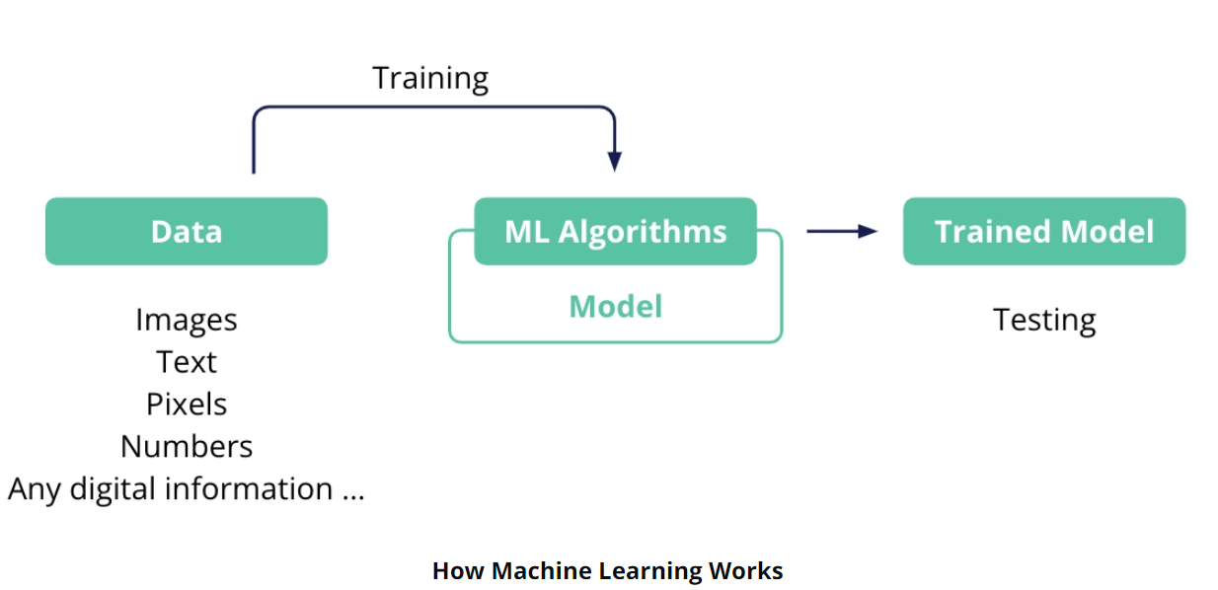

### **Key Terms and Concepts**

1. **Machine Learning (ML)** -The compass directing computers towards autonomous learning and pattern discernment from data, under the vast umbrella of AI.
2. **Machine Learning System** - The harmonious blend of data, ML algorithms, and a machine learning model.
3. **Machine Learning Model** - The system's intellect, processing data through algorithms to forge predictions or decisions.
4. **Training** - The saga of nurturing the model by processing data through the ML algorithm code.
5. **Testing** - The act of gauging the model's mettle using new data, post-training.
6. **Iteration** - The cycle of tweaking algorithms and data, coupled with re-training, aiming to uplift model performance.

# Types of Machine Learning

## **Right Learning Path: Supervised, Unsupervised, and Reinforcement Learning Explained**

When embarking on creating a machine learning model, one of the first choices you'll need to make is the type of learning approach to use. This decision hinges on the kind of data you have and the problem you're tackling. Here’s a simple breakdown of the three primary learning types: Supervised, Unsupervised, and Reinforcement Learning.

### **Supervised Learning**

* **Like Learning with a Teacher** - You provide the model with data and the correct answers (labels) for each data point, much like showing a picture of a cat and telling the model it's a cat.
* **When to Use -** If you have labeled data and you want the model to learn the right answer from this data.
* **Examples -** Classifying images, speech recognition, self-driving car tasks like identifying pedestrians, bank fraud detection.

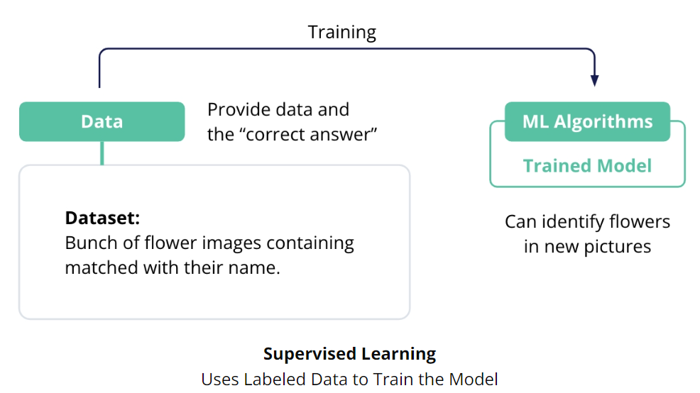

### **Unsupervised Learning**

* **Learning on its Own -** The model explores a lot of data on its own to find patterns and structures, akin to solving a puzzle without seeing the picture on the box.
* **When to Use -** If you have unlabeled data and you want the model to find patterns or structures in the data.
* **Examples** - Generating new songs, writing code, handling massive datasets with unlabeled data.

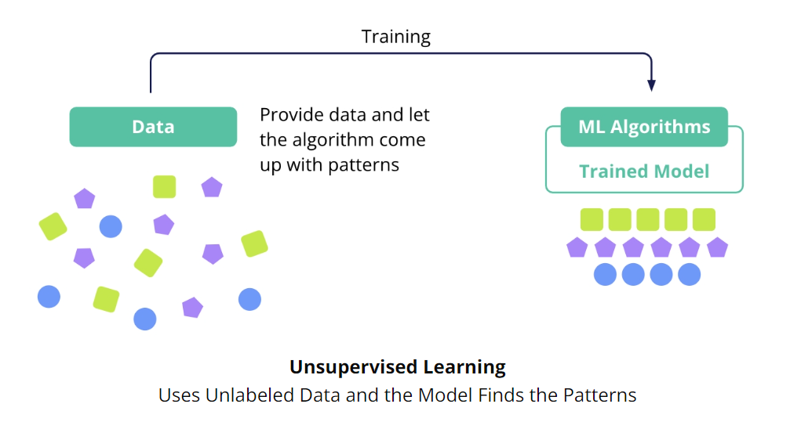

### **Reinforcement Learning**

* **Learning by Trial and Error -** The model learns by interacting with an environment, receiving rewards for right actions and penalties for wrong ones, much like training a pet.
* **When to Use -** When you want your model to learn from its interactions and feedback, without needing labeled data.
* **Examples -** Playing video games, robotics, real-time decision-making in self-driving cars.

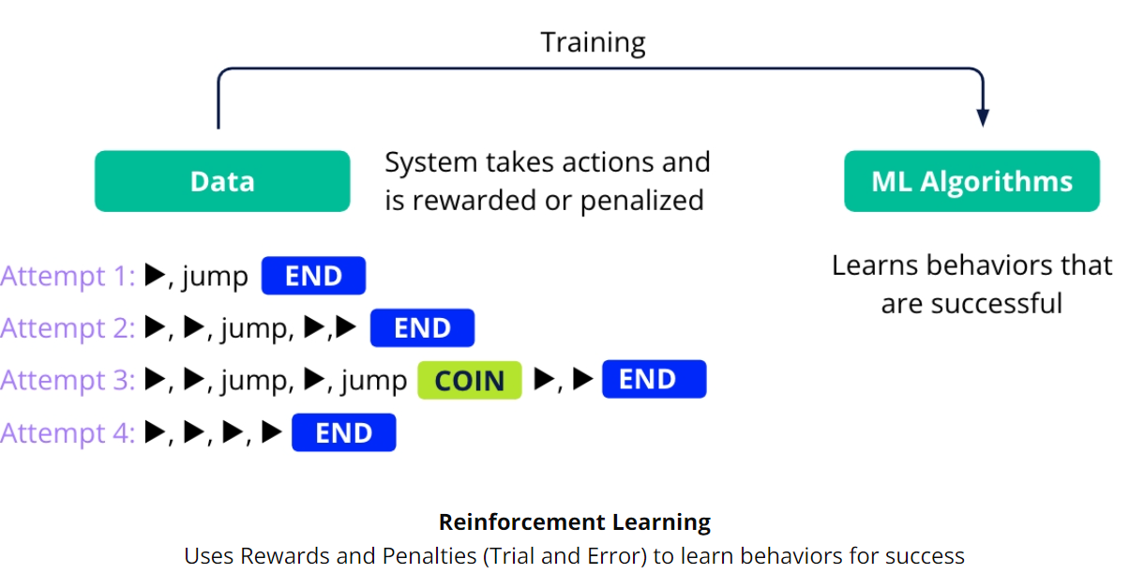

In more complex real-world problems, a blend of these learning types might be employed, with multiple models each handling specific tasks, much like a team of specialists working together towards a common goal.

# Supervised vs Unsupervised

1. Click **Launch Cloud Gateway** in the bottom of the navigation menu
2. From the AWS console, search for **SageMaker**, in the left side menu click **Notebooks**, then click **Notebook instances**
3. Click **Create notebook instance**
4. When the instance is ready, click **Open Jupyter**
5. When in the notebook, click **New** and select **conda\_python3**
6. Copy the code below on this page and paste it into a notebook cell, then run the cell
   * **Supervised learning**
   * **Unsupervised learning**
7. **Delete the notebook instance after reviewing the solution on the next page.**

## **Part 1: Predicting Building Energy Efficiency (Supervised Learning)**

**Scenario** - You are working for an architecture firm, and your task is to build a model that predicts the energy efficiency rating of buildings based on features like wall area, roof area, overall height, etc.

### **Supervised Learning Code: To predict the energy efficiency of buildings.**

# Import necessary libraries

import pandas as pd

import numpy as np

import matplotlib.pyplot as plt

import seaborn as sns

import warnings

from sklearn.model\_selection import train\_test\_split

from sklearn.ensemble import RandomForestRegressor

from sklearn.metrics import mean\_squared\_error

warnings.filterwarnings('ignore')

# Generate synthetic dataset for building features and energy efficiency ratings

np.random.seed(0)

data\_size = 500

data = {

    'WallArea': np.random.randint(200, 400, data\_size),

    'RoofArea': np.random.randint(100, 200, data\_size),

    'OverallHeight': np.random.uniform(3, 10, data\_size),

    'GlazingArea': np.random.uniform(0, 1, data\_size),

    'EnergyEfficiency': np.random.uniform(10, 50, data\_size)  # Energy efficiency rating

}

df = pd.DataFrame(data)

# Data preprocessing

X = df.drop('EnergyEfficiency', *axis*=1)

y = df['EnergyEfficiency']

# Visualize the relationships between features and the target variable (Energy Efficiency)

sns.pairplot(df, *x\_vars*=['WallArea', 'RoofArea', 'OverallHeight', 'GlazingArea'], *y\_vars*='EnergyEfficiency', *height*=4, *aspect*=1, *kind*='scatter')

plt.show()

# Split the data into training and testing sets

X\_train, X\_test, y\_train, y\_test = train\_test\_split(X, y, *test\_size*=0.2, *random\_state*=42)

# Train a Random Forest model

model = RandomForestRegressor()

model.fit(X\_train, y\_train)

# Predict and evaluate

predictions = model.predict(X\_test)

mse = mean\_squared\_error(y\_test, predictions)

print(*f*"Mean Squared Error: {mse}")

# Plot the True values vs Predicted values

plt.figure(*figsize*=(10, 6))

plt.scatter(y\_test, predictions)

plt.xlabel("True Values")

plt.ylabel("Predictions")

plt.title("True Values vs Predicted Values")

plt.plot([y\_test.min(), y\_test.max()], [y\_test.min(), y\_test.max()], 'k--')

plt.show()

## **Part 2: Vehicle Clustering (Unsupervised Learning)**

**Scenario** - You are working for an automotive company, and your task is to cluster vehicles into groups based on their features such as weight, engine size, and horsepower.

### **Unsupervised Learning Code: To cluster vehicles based on their specifications.**

# Import necessary libraries

import pandas as pd

import numpy as np

import matplotlib.pyplot as plt

import warnings

from sklearn.cluster import KMeans

warnings.filterwarnings('ignore')

# Generate synthetic dataset for vehicles

np.random.seed(0)

data\_size = 300

data = {

    'Weight': np.random.randint(1000, 3000, data\_size),

    'EngineSize': np.random.uniform(1.0, 4.0, data\_size),

    'Horsepower': np.random.randint(50, 300, data\_size)

}

df = pd.DataFrame(data)

# No labels are needed for unsupervised learning

X = df

# Perform KMeans clustering

kmeans = KMeans(*n\_clusters*=3, *random\_state*=42)

kmeans.fit(X)

# Plotting the clusters

plt.scatter(df['Weight'], df['Horsepower'], *c*=kmeans.labels\_)

plt.xlabel('Weight')

plt.ylabel('Horsepower')

plt.title('Vehicle Clusters')

plt.show()

These programmes use synthetic data for simplicity and demonstration purposes. In real-world applications, actual data and more complex models might be used. The choice of algorithms - **RandomForestRegressor** for supervised learning and **KMeans** for unsupervised learning - is based on their general applicability and ease of understanding for educational purposes.

## **Supervised Learning Exercise: Predicting Building Energy Efficiency**

 you trained a RandomForestRegressor model to predict the energy efficiency of buildings based on features such as wall area, roof area, overall height, and glazing area.

### **Expected Results**

1. **Data Visualizations** - Scatter plots will show the relationship between each feature and the target variable (energy efficiency). Students should observe how changes in features may relate to energy efficiency, although with synthetic data, these relationships might not show clear trends.
2. **Model Performance** - After training the model and making predictions, students will evaluate the model using Mean Squared Error (MSE). With synthetic data, the MSE value may vary, but it gives an idea of the average error in the model's predictions. The closer this value is to zero, the better the model's performance.
3. **Prediction vs. True Value Plot** - The scatter plot comparing true values and model predictions should ideally show points along the diagonal line (y=x), indicating accurate predictions. Deviations from this line suggest prediction errors.
4. **Remember to delete the notebook instance.**

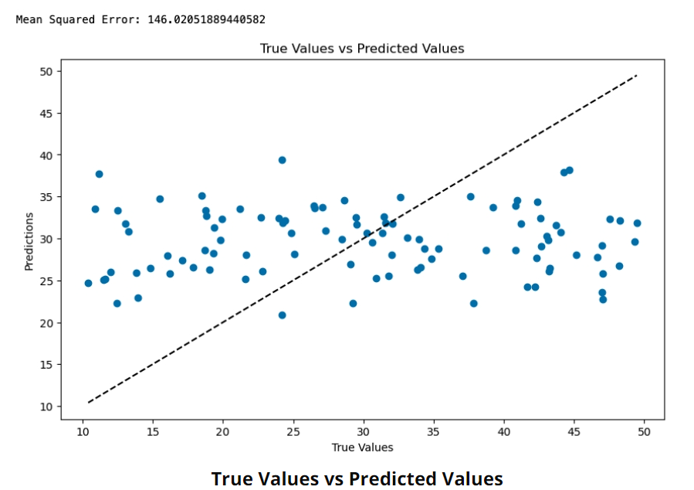

## **Unsupervised Learning Exercise: Vehicle Clustering**

In this exercise, you used KMeans clustering to group vehicles based on their features like weight, engine size, and horsepower.

### **Expected Results**

1. **Cluster Visualization** - The scatter plot will visually depict how vehicles are grouped based on weight and horsepower. Each cluster will be represented by a different color. With synthetic data, the distinctness of clusters may vary, but students should be able to see groupings based on the chosen features.
2. **Interpreting Clusters** - There are no 'correct' labels in unsupervised learning, but students should observe how vehicles are grouped based on similarities in their features. They might see, for example, that heavier vehicles with higher horsepower are grouped together.

In both tasks, the exact numerical results can vary based on the randomness in the synthetic data generation and the inherent variability in machine learning models. The key learning outcome is understanding the process of applying machine learning techniques and interpreting the results, rather than achieving specific numerical accuracy or clustering results.

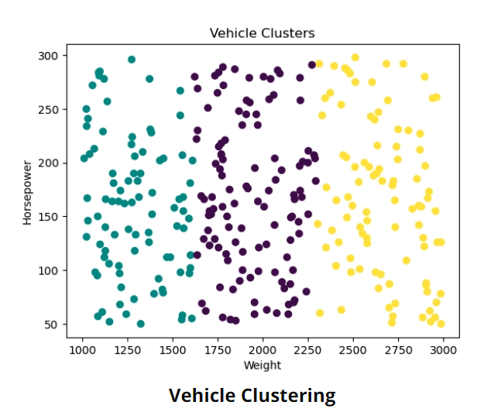

# Algorithms and Models

## **Machine Learning Approaches**

Building a machine learning model involves deciding on the learning type, selecting an approach or algorithm, and then training the model to optimize its performance. This journey begins with traditional machine learning approaches like:

* **Decision Trees**
* **Regression**
* **Clustering Algorithms**

which are apt for structured data. However, for handling large volumes of unstructured data and achieving high accuracy in complex tasks, deep learning, powered by neural networks, becomes the go-to.

The choice between traditional machine learning and deep learning hinges on the data, the problem at hand, and the available resources.

### **Traditional Machine Learning**

* **Decision Trees** - Flowchart-like structures aiding in decision-making based on data features.
* **Regression Algorithms** - Useful for predicting numerical values by modeling relationships between variables.
* **Clustering Algorithms** - Group data into clusters based on similarity, aiding in data segmentation and categorization.

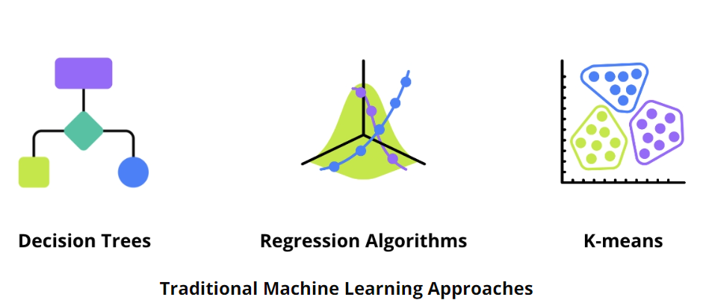

### **Deep Learning**

* **Artificial Neural Networks** - Inspired by the human brain, these networks excel in processing huge amounts of data and learning patterns from it.
* **Convolutional Neural Networks (CNNs)** - Specialized for vision tasks, preserving spatial context of images.
* **Recurrent Neural Networks (RNNs)** - Efficient for sequential data, aiding in tasks like predictive text.

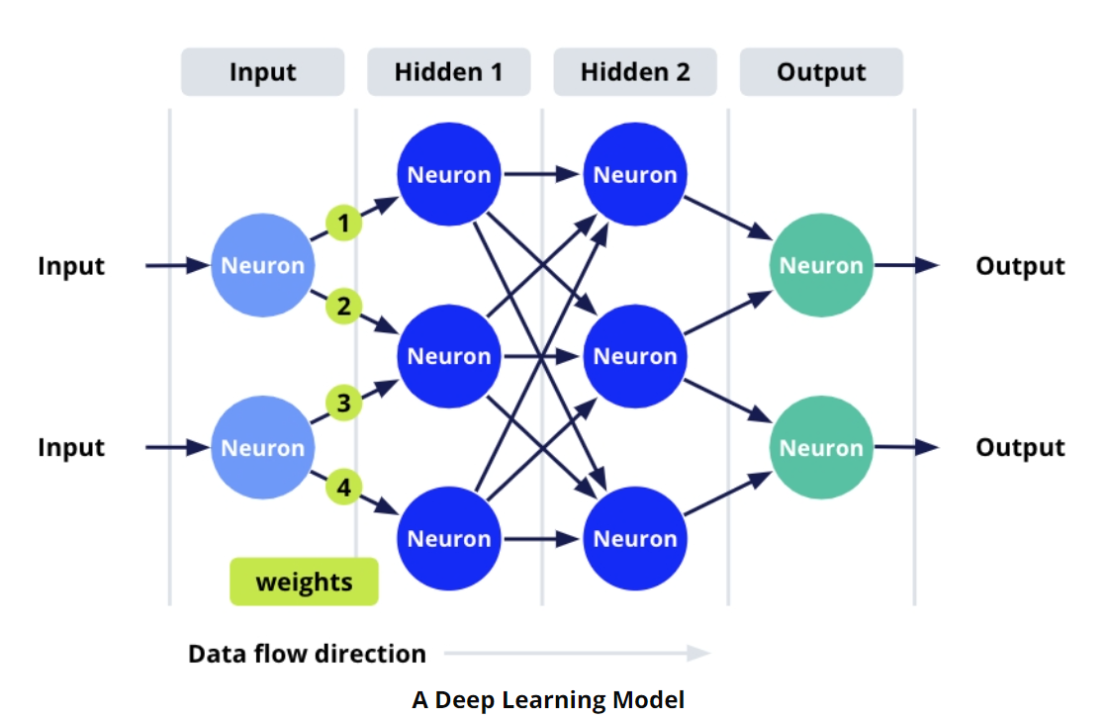

### **Advanced Deep Learning**

* **Generative Models** - Aim to generate new data samples similar to input data, useful in creating new content.
* **Transformer Architecture** - Consisting of encoders and decoders, crucial in language translation and code generation tasks.

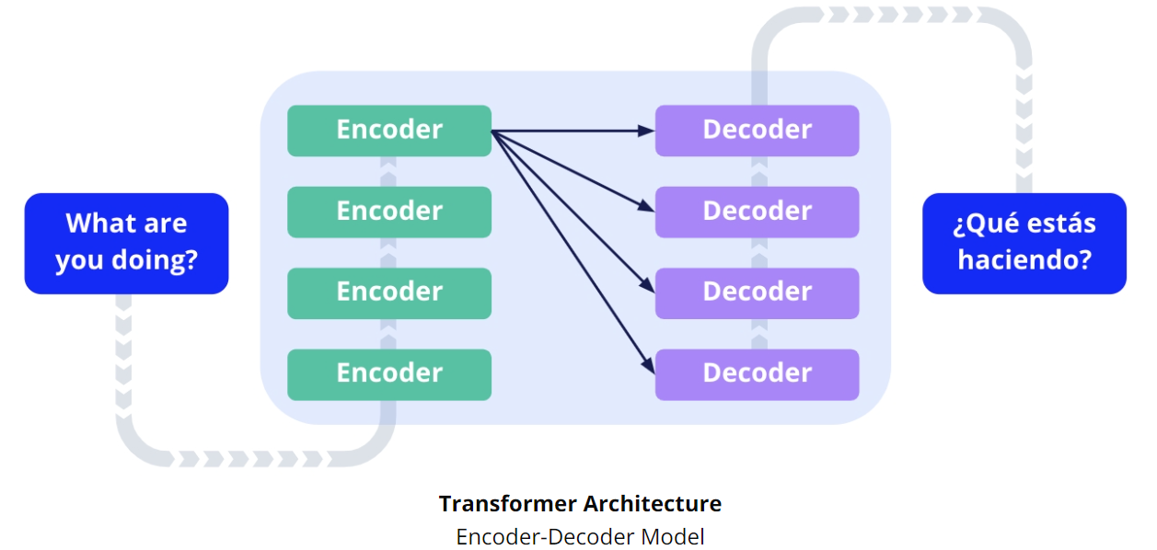

## **Building a Decision Tree to Predict Customer Churn**

Imagine you are a data analyst at a telecom company. The marketing department has noticed an increase in customer churn and needs your help to identify which customers are most likely to leave next month.

### **Your Tasks**

In this exercise, you will build a decision tree model to predict customer churn for a telecom company. **Customer churn** refers to when a customer stops doing business with a company. Predicting churn is crucial for businesses to retain customers by addressing their issues proactively.

1. Click **Launch Cloud Gateway** in the bottom of the navigation menu
2. From the AWS console, search for **SageMaker**, in the left side menu click **Notebooks**, then click **Notebook instances**
3. Click **Create notebook instance**
4. When the instance is ready, click **Open Jupyter**
5. When in the notebook, click **New** and select **conda\_python3**
6. Copy the code below on this page and paste it into a notebook cell, then run the cell
7. **Delete the notebook instance after reviewing the solution on the next page.**

### **Dataset Description**

We will use a synthetic dataset for this exercise. The dataset contains the following columns:

* **CustomerID:** A unique identifier for each customer.
* **Age:** The age of the customer.
* **MonthlyCharge:** The monthly bill amount for the customer.
* **CustomerServiceCalls:** The number of times the customer contacted customer service.
* **Churn:** This is our target variable, indicating whether the customer churned (Yes) or not (No).

#### Step-by-Step Instructions

1. **Setup the Environment:**
   * Import necessary libraries: Pandas for data manipulation, Scikit-learn for machine learning, and Matplotlib for visualization.
2. **Create the Dataset:**
   * Use Python to create a synthetic dataset. We'll make a small dataset for simplicity.
3. **Data Preparation:**
   * Split the data into features (X) and the target variable (y).
   * Further split the dataset into training and testing sets.
4. **Build the Decision Tree Model:**
   * Use Scikit-learn to create a DecisionTreeClassifier.
   * Train the model on the training data.
5. **Evaluate the Model:**
   * Make predictions on the test set.
   * Calculate the accuracy of the model.
6. **Visualize the Decision Tree:**
   * Use Matplotlib to visualize how the decision tree makes decisions.
7. **Discuss the Results:**
   * Interpret the decision tree.
   * Discuss how it can be used by the company to reduce customer churn.

### **Python Code Implementation**

# Import necessary libraries

import pandas as pd

import matplotlib.pyplot as plt

import warnings

from sklearn.model\_selection import train\_test\_split

from sklearn.tree import DecisionTreeClassifier

from sklearn.metrics import accuracy\_score

from sklearn import tree

warnings.filterwarnings('ignore')

# Creating a synthetic dataset

# This dataset simulates customer data for a telecom company

data = {

    'CustomerID': range(1, 101),  # Unique ID for each customer

    'Age': [20, 25, 30, 35, 40, 45, 50, 55, 60, 65]\*10,  # Age of customers

    'MonthlyCharge': [50, 60, 70, 80, 90, 100, 110, 120, 130, 140]\*10,  # Monthly bill amount

    'CustomerServiceCalls': [1, 2, 3, 4, 0, 1, 2, 3, 4, 0]\*10,  # Number of customer service calls

    'Churn': ['No', 'No', 'Yes', 'No', 'Yes', 'No', 'Yes', 'Yes', 'No', 'Yes']\*10  # Churn status

}

df = pd.DataFrame(data)

# Splitting the dataset into features and target variable

# Features include age, monthly charge, and customer service calls

# The target variable is churn (Yes or No)

X = df[['Age', 'MonthlyCharge', 'CustomerServiceCalls']]

y = df['Churn']

# Splitting the dataset into training and testing sets

# 70% of the data is used for training and 30% for testing

X\_train, X\_test, y\_train, y\_test = train\_test\_split(X, y, *test\_size*=0.3, *random\_state*=42)

# Training the Decision Tree model

clf = DecisionTreeClassifier()

clf.fit(X\_train, y\_train)

# Making predictions on the test set

y\_pred = clf.predict(X\_test)

# Evaluating the model using accuracy

# Accuracy is the proportion of correct predictions among the total number of cases processed

accuracy = accuracy\_score(y\_test, y\_pred)

print(*f*'Model Accuracy: {accuracy}')

# Visualizing the decision tree

# This visualization helps in understanding how the model makes decisions

plt.figure(*figsize*=(12,8))

tree.plot\_tree(clf, *filled*=True, *feature\_names*=['Age', 'MonthlyCharge', 'CustomerServiceCalls'], *class\_names*=['No Churn', 'Churn'])

plt.title('Decision Tree for Predicting Customer Churn')

plt.show()

When you visualize a decision tree, especially one created using Scikit-learn's DecisionTreeClassifier, you'll notice several terms on each node of the tree. Understanding these terms is crucial for interpreting the tree's decision-making process. Let's break down each of these terms:

1. **Gini**
   * The Gini impurity is a measure of how often a randomly chosen element from the set would be incorrectly labeled if it was randomly labeled according to the distribution of labels in the subset.
   * The Gini impurity ranges from 0 to 0.5, where 0 indicates that all elements in the subset belong to the same class (perfect purity), and 0.5 means the data is randomly distributed across various classes.
   * In decision trees, a lower Gini impurity is generally preferred as it indicates greater purity of the node.
2. **Samples**
   * This value represents the number of samples (or records) that reach the node.
   * It gives an idea of how much of the training data is affected by the conditions leading to this node.
   * A high number of samples in a node means that the condition or rule associated with that node is relevant for a significant portion of the dataset.
3. **Value**
   * This shows the distribution of the samples in different classes at that particular node.
   * For a binary classification problem (like churn prediction with 'Yes' or 'No'), the value is presented as a list of two numbers. The first number indicates the count of samples in the first class, and the second number indicates the count of samples in the second class.
   * This distribution helps in understanding which class is predominant at a particular node.
4. **Class**
   * This indicates the class that would be predicted if the decision tree traversal ends at that node.
   * It is determined based on the majority class of the samples that reach the node. For instance, if most samples at a node belong to the 'No Churn' class, the node will predict 'No Churn'.
5. **Feature Name (e.g., 'Monthly Charge')**
   * This is not a standard part of the decision tree node description, but it may appear in the tree's branches.
   * It represents the feature (or attribute) used to split the data at that node.
   * For example, if you see "MonthlyCharge <= 80", it means that the tree is splitting the data at this node based on whether the monthly charge is less than or equal to 80.

Understanding these components is essential for interpreting how the decision tree makes its predictions and which features are influential in the decision-making process. This can provide valuable insights, especially in business contexts like customer churn prediction.

### **Key Concepts**

1. **Splitting the Dataset** - The dataset is divided into training and testing sets. Typically, 70% of the data is used for training the model, and the remaining 30% is reserved for testing.
2. **Training Data vs. Testing Data** - Training data is used to train the machine learning model. In contrast, testing data, which the model has not seen during training, is used to evaluate the model's performance and generalization ability.
3. **Model Training Process** - The process involves using a 'fit' method where the model is trained using features (X\_train) and targets (Y\_train). The testing data is not used in this stage.
4. **Prediction and Accuracy Assessment** - After training, the model makes predictions on the test data (X\_test). These predictions are then compared with the actual outcomes (Y\_test) to calculate the model's accuracy.

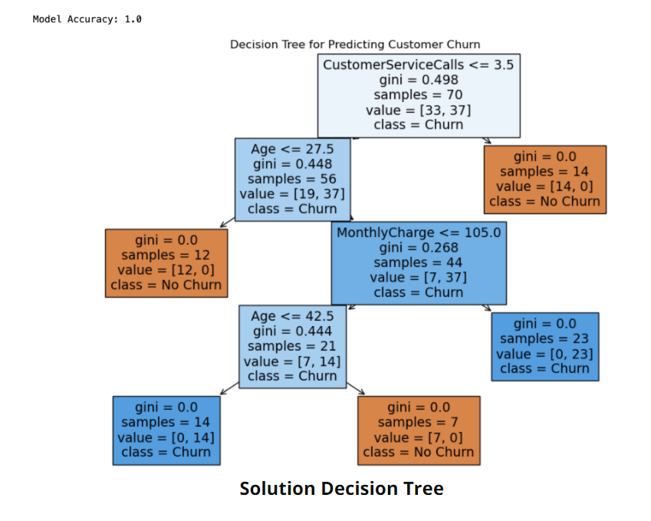

# Neural Networks

 We'll use a synthetic dataset to predict whether a customer will make a purchase based on two features:

1. Website visit duration
2. Number of pages visited.

This is a **binary classification problem**, and we'll use a small neural network for quick execution.

### **Step 1: Set Up AWS SageMaker Notebook**

* Launch a new SageMaker notebook instance.
* Open a new Jupyter notebook in the instance.
* Choose kernel **conda\_tensorflow2\_p310**.

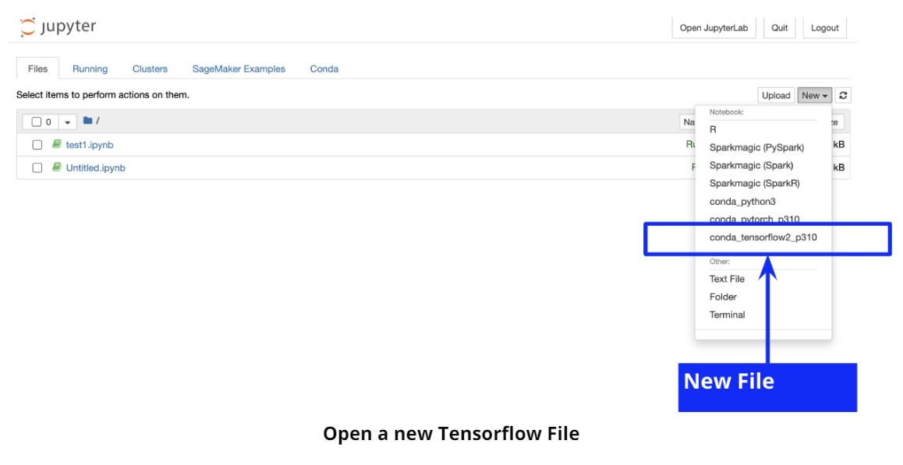

### **Step 2: Generate Synthetic Data**

import numpy as np

import pandas as pd

import warnings

warnings.filterwarnings('ignore')

# Generating synthetic data

np.random.seed(0)

data\_size = 200

features = np.random.rand(data\_size, 2)  # Two features: visit duration and pages visited

labels = (features[:, 0] + features[:, 1] > 1).astype(int)  # Purchase (1) or not (0)

# Convert to DataFrame for easier manipulation

df = pd.DataFrame(features, *columns*=['VisitDuration', 'PagesVisited'])

df['Purchase'] = labels

### **Step 3: Preprocess the Data**

from sklearn.model\_selection import train\_test\_split

# Split the data

X\_train, X\_test, y\_train, y\_test = train\_test\_split(df[['VisitDuration', 'PagesVisited']], df['Purchase'], *test\_size*=0.2, *random\_state*=42)

### **Step 4: Build and Train the Neural Network**

import tensorflow as tf

from tensorflow.keras.models import Sequential

from tensorflow.keras.layers import Dense

# Define the model

model = Sequential([

    Dense(10, *activation*='relu', *input\_shape*=(2,)),  # Input layer with 2 features

    Dense(1, *activation*='sigmoid')  # Output layer with sigmoid activation for binary classification

])

# Compile the model

model.compile(*optimizer*='adam', *loss*='binary\_crossentropy', *metrics*=['accuracy'])

# Train the model

model.fit(X\_train, y\_train, *epochs*=10, *batch\_size*=10)

### **Step 5: Evaluate the Model**

# Evaluate the model on the test set

loss, accuracy = model.evaluate(X\_test, y\_test)

print(*f*"Test Accuracy: {accuracy}")

Unlike decision trees, neural networks are not easily visualizable in terms of their decision-making process because they are considered "black box" models. However, there are some aspects of neural network models that you can visualize to gain insights. For the given example, we can visualize the following:

1. **Training Process** - You can plot the training and validation loss and accuracy over epochs to understand how the model is learning.
2. **Decision Boundary** - For a simple neural network like the one in our example (with two input features), you can visualize the decision boundary on a 2D plot.

Here's how you can implement these visualizations -

### **Model Accuracy and Loss**

In the context of the neural network exercise for predicting customer purchase behavior, "model accuracy" and "model loss" are two important metrics used to evaluate the performance of the model. Here's a concise explanation of each:

1. **Model Accuracy** is the fraction of predictions our model got right. In the context of the exercise, it is the proportion of correctly predicted purchase decisions (both purchases and non-purchases) out of all predictions made.
   * **Formula** - Accuracy = (Number of Correct Predictions) / (Total Number of Predictions)
   * **Interpretation** - a higher accuracy indicates a better performing model. For example, an accuracy of 0.90 means that 90% of the model's predictions are correct.
2. **Model Loss** measures how far the model's predictions are from the actual class labels. It is a measure of the model's error.
   * **Binary Cross-Entropy** - is commonly used in binary classification tasks. It calculates the loss for each instance by comparing the predicted probability with the actual label (either 0 or 1), and then takes the average over all instances.
   * **Interpretation** - lower loss values are better, indicating that the model's predictions are closer to the actual labels. A high loss value means the model's predictions are far off from the actual labels.

#### Visualizing Training Process

You can modify the training code to save the history of training and then plot it:

#Supress Warnings

import warnings

warnings.filterwarnings('ignore')

# Train the model and save the history

history = model.fit(X\_train, y\_train, *epochs*=10, *batch\_size*=10, *validation\_split*=0.2)

# Plotting training and validation loss and accuracy

import matplotlib.pyplot as plt

plt.figure(*figsize*=(12, 5))

# Plot training & validation accuracy values

plt.subplot(1, 2, 1)

plt.plot(history.history['accuracy'])

plt.plot(history.history['val\_accuracy'])

plt.title('Model accuracy')

plt.ylabel('Accuracy')

plt.xlabel('Epoch')

plt.legend(['Train', 'Validation'], *loc*='upper left')

# Plot training & validation loss values

plt.subplot(1, 2, 2)

plt.plot(history.history['loss'])

plt.plot(history.history['val\_loss'])

plt.title('Model loss')

plt.ylabel('Loss')

plt.xlabel('Epoch')

plt.legend(['Train', 'Validation'], *loc*='upper left')

plt.show()

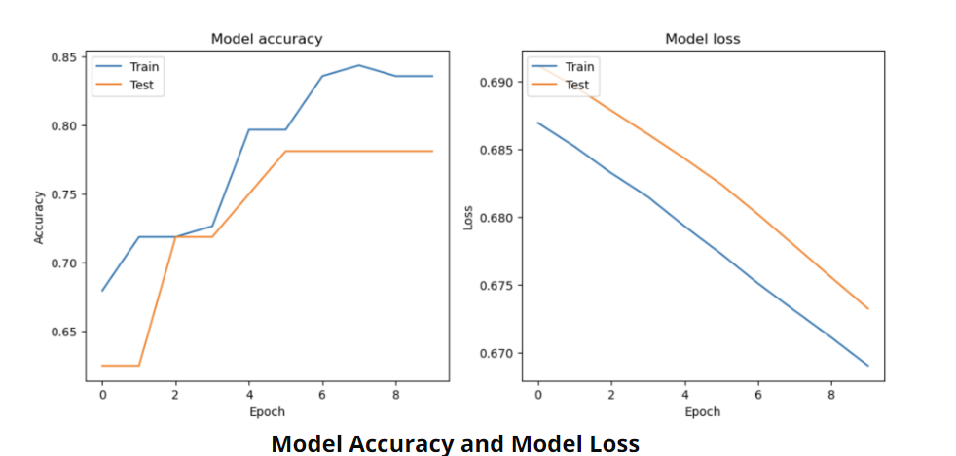

### **Decision Boundary**

In the context of the neural network exercise for predicting customer purchase behavior, the decision boundary is a concept used to visualize how the neural network categorizes or classifies the data.

The **Decision Boundary** is a boundary in the feature space that separates the data points into different classes based on the predictions made by the model. In our exercise, we have two input features: website visit duration and number of pages visited. The decision boundary will be a line or curve in this 2-dimensional space that separates the points predicted to make a purchase (class 1) from those predicted not to make a purchase (class 0).

* **How It's Determined** - The neural network learns the decision boundary during training. It adjusts its internal parameters (weights and biases) to correctly classify the training data. The boundary is where the model's output (before applying a threshold) is at some critical value, often 0.5 for binary classification with a sigmoid output. Points on one side of the boundary are classified as one class, and points on the other side as the other class.
* **Visualization** - In the plot, the decision boundary is typically represented by a line or contour. Points falling on one side of the boundary are predicted to be in one class, and those on the other side in the other class. The decision boundary can be linear or non-linear depending on the complexity of the model and the nature of the data.

The decision boundary in our neural network example serves as a visual tool to understand how the model differentiates between customers likely to make a purchase and those who are not, based on their website engagement metrics.

#### Creating the Visual

For a simple model with two input features, you can plot the decision boundary:

# Generate a grid over the feature space

x\_min, x\_max = df['VisitDuration'].min() - 0.1, df['VisitDuration'].max() + 0.1

y\_min, y\_max = df['PagesVisited'].min() - 0.1, df['PagesVisited'].max() + 0.1

xx, yy = np.meshgrid(np.linspace(x\_min, x\_max, 100), np.linspace(y\_min, y\_max, 100))

# Predict over the grid

Z = model.predict(np.c\_[xx.ravel(), yy.ravel()])

Z = Z.reshape(xx.shape)

# Plot the contour and training examples

plt.contourf(xx, yy, Z, *alpha*=0.8)

plt.scatter(df['VisitDuration'], df['PagesVisited'], *c*=df['Purchase'], *edgecolor*='k')

plt.xlabel('Visit Duration')

plt.ylabel('Pages Visited')

plt.title('Decision Boundary of Neural Network')

plt.show()

these visualizations are more about understanding the model's structure and learning process rather than explaining its decision-making process in detail, which is more straightforward with models like decision trees.

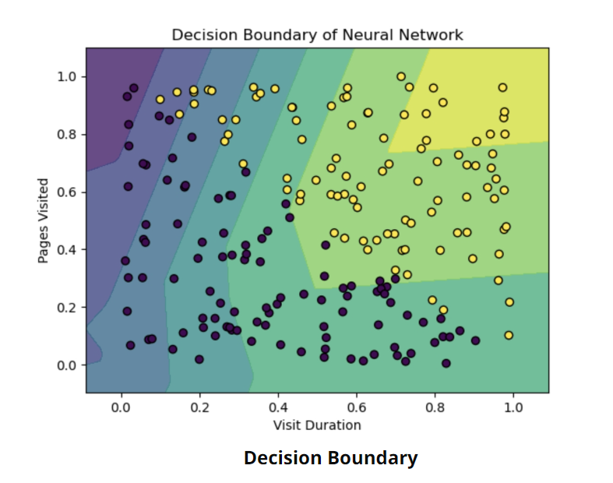

# Discriminative, Predictive, and Generative AI

## **Discriminative Models**

Machine Learning (ML) has progressed significantly with the advent of Deep Learning and Transformer Architecture, providing two prime categories:

1. **Discriminative (Predictive) AI**
2. **Generative AI**

Discriminative AI excels in categorization, and spotting boundaries in data to predict outcomes. Examples of discriminative models include:

* **Decision Trees**
* **Linear Regression**
* **Convolutional Neural Networks (CNNs)**
* **Recurrent Neural Networks (RNNs**)

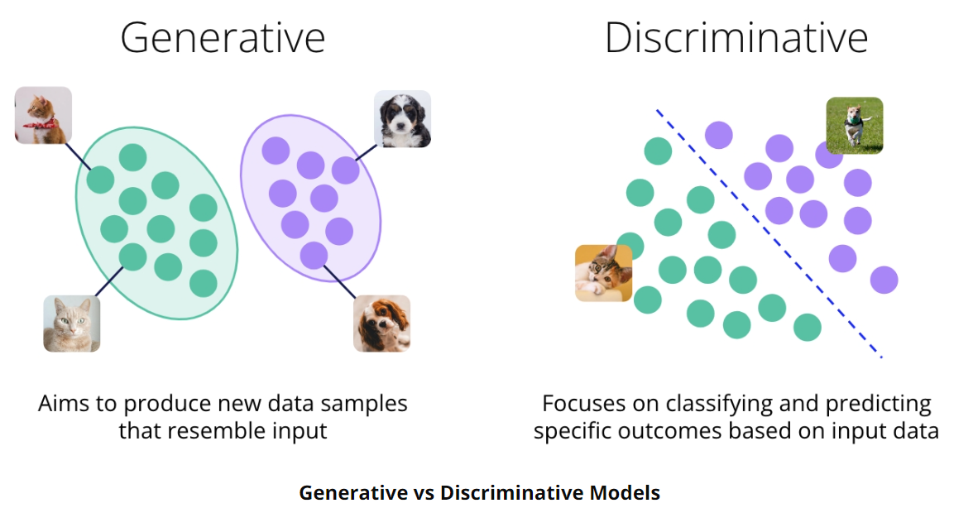

## **Generative AI**

Generative AI shines in creating new data resembling the input, with models like:

* Generative Adversarial Networks
* Variational Autoencoders

The choice between these paths is based on:

* Task complexity
* Data quality
* Computational resources.

# Introduction to Understanding and Using Large Language Models (LLMs)

## **Introduction to Large Language Models**

In this lesson, we delve into the fascinating world of Large Language Models (LLMs), extraordinary tools at the forefront of artificial intelligence. LLMs are not just theoretical constructs but practical tools, aiding in tasks like writing emails, generating creative content, and interpreting complex information.

**Large Language Models (LLMs)** - Advanced machine learning systems that understand and generate human language, mimicking human-like conversation and writing.

**Prompt Engineering** - A skill to effectively use LLMs, involving the crafting of inputs to get desired outputs.

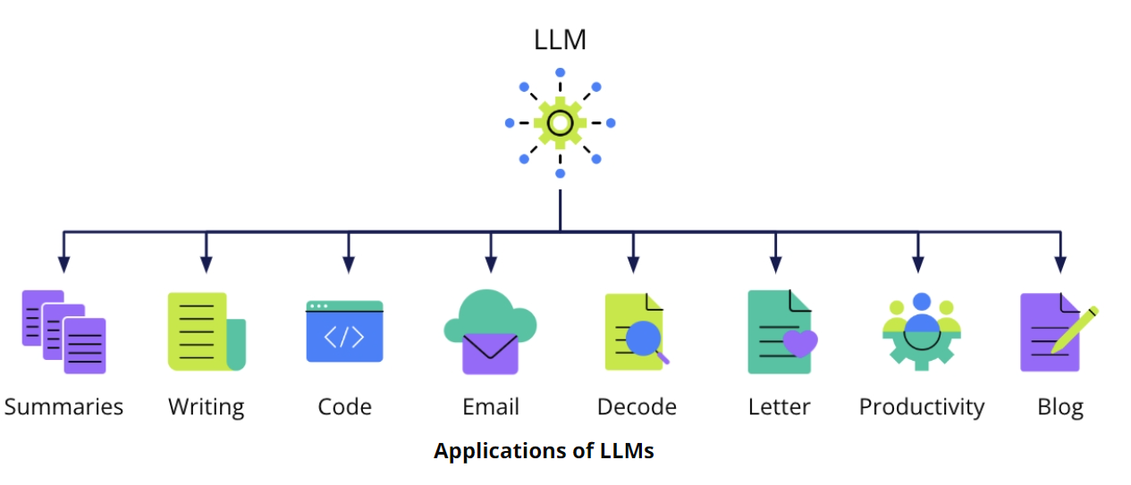

### **Applications of LLMs**

* Crafting professional emails.
* Generating creative writing prompts.
* Simplifying complex information into summaries.
* Assisting in writing heartfelt letters, blog ideas, or decoding legal documents.
* Writing code and enhancing productivity at work.

# What is a Large Language Model (LLM)

## **Understanding Large Language Models (LLMs)**

Large Language Models (LLMs) represent a significant advancement in artificial intelligence, specializing in processing, understanding, and generating human language. These models are distinguished by their size, both in terms of the vast number of parameters and their extensive training data.

### **Key Characteristics**

1. **Extensive Training Data -** LLMs are trained on a wide array of text sources, enabling them to learn diverse linguistic patterns and styles.
2. **High Capacity -** With billions of parameters, LLMs can store and recall extensive information about language.
3. **Deep Understanding -** They can comprehend context and nuances in language, performing complex tasks like summarization, translation, and conversation.
4. **Transformer Architecture -** Most LLMs use transformer architecture for efficient text processing and adaptable attention to different parts of the input.
5. **Content Generation -** Capable of generating coherent and contextually relevant text, including essays, poetry, and code.

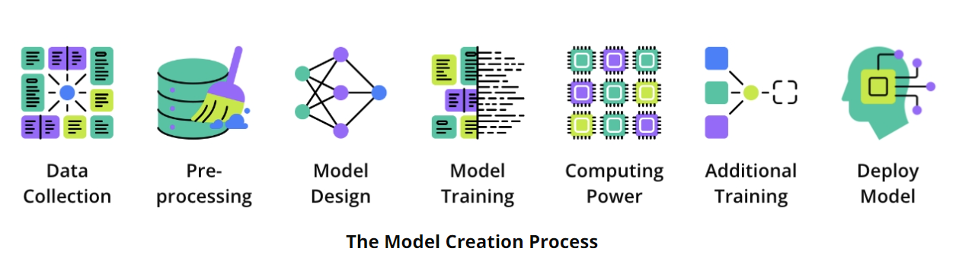

### **Creation Process**

1. **Data Collection -** Gathering a large and varied dataset from multiple text sources.
2. **Pre-processing -** Cleaning and preparing the data for training.
3. **Model Design -** Selecting a neural network architecture, typically a transformer model.
4. **Training -** Using machine learning algorithms to improve the model's accuracy in predicting text sequences.
5. **Computing Power -** Requiring powerful GPUs or TPUs for processing and training.
6. **Additional Training -** Further training on specific datasets for specialized tasks.
7. **Deploying the Model -** Making the model available for user queries and prompts.

### **Challenges and Accessibility**

* Creating an LLM requires immense computational resources, data management, and expertise.
* Ensuring fairness, lack of bias, and user privacy are crucial considerations.
* Although resource-intensive to develop, LLMs are often made accessible to the public via APIs and applications.

# LLMs for Code Generation

## **Code Generation**

**Amazon CodeWhisperer** is a tool designed to enhance software developers' efficiency. It excels in using an LLM to generate code snippets from text prompts, reducing time spent on routine coding and allowing developers to focus on complex tasks.

### **How It Works**

Using the AWS Cloud9 editor:

* Users simply input a comment describing the desired function.
* Amazon CodeWhisperer then uses autocomplete to suggest relevant code.

This service significantly reduces the time spent on writing standard boilerplate code, allowing developers to focus on more complex, value-adding aspects of their projects.

# Natural Language Models

## **Exploring Natural Language Processing (NLP)**

Natural Language Processing (NLP) is a critical field within artificial intelligence, combining computational linguistics with machine learning and deep learning techniques to enable computers to process and understand human language in both text and voice forms.

### **Key Processes in NLP**

1. **Tokenization -** Breaking down text into smaller units (tokens), such as words or phrases, for easier analysis.
2. **Parsing -** Analyzing the grammatical structure of sentences to understand how words relate to each other.
3. **Semantic Analysis -** Understanding the meaning behind words by considering context, synonyms, and ambiguities.
4. **Contextual Understanding -** Utilizing the context of surrounding sentences to enhance interpretation, including understanding implied meanings and intentions.
5. **Statistical Inference -** Using probabilities to predict subsequent words or appropriate responses in a conversation.
6. **Machine Learning Integration -** Continuously learning from new inputs to improve language prediction and understanding.

NLP is crucial in enabling machines to decode human language, comprehend the intended meaning, and generate coherent, relevant responses.

It represents a complex interplay of various processes that equip machines with linguistic understanding capabilities.

# Evolution of Large Language Models

## **The Evolution of Large Language Models (LLMs)**

The journey of Large Language Models (LLMs) in Natural Language Processing (NLP) is a story of increasing sophistication and capability. Starting from rule-based systems and progressing through various stages of machine learning and deep learning, LLMs have become adept at understanding and generating human-like text.

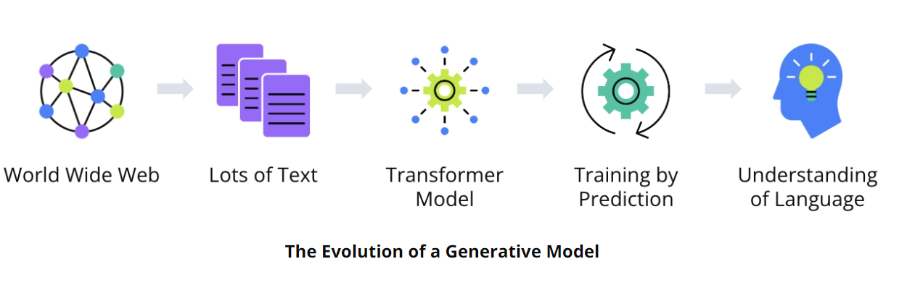

### **Evolutionary Stages**

1. **Rule-Based Systems -** Early models based on explicit grammatical and syntactic rules, limited and inflexible.
2. **Statistical Models -** Shifted to probability-based predictions, enabling more complex language processing.
3. **Machine Learning Models -** Began understanding context and patterns, but struggled with long-range dependencies.
4. **Neural Networks (RNNs and LSTMs) -** Improved handling of sequences and memory, marking significant progress.
5. **Transformer-Based Architectures -** Introduced attention mechanisms, allowing models to weigh the importance of each part of the sentence, thus capturing intricate relationships and context.

### **Capabilities of Modern LLMs**

* LLMs, particularly those based on transformer architectures, demonstrate a deep understanding of context and relationships within text.
* They can predict and generate text coherently, using the context from preceding text.
* LLMs are capable of performing complex tasks like translation, conversation, and content creation, with a nuanced understanding of language.

# How Large Language Models Work

## **Processing and Learning from Text with Transformer Models**

Understanding how transformer models process language is crucial in appreciating the capabilities of Large Language Models (LLMs). These models use a series of intricate steps to convert text into a numerical format that can be processed by neural networks, leading to a deep understanding of language.

### **Key Concepts**

1. **Transformer-Based Architectures** - These are types of neural network architectures that have become fundamental in state-of-the-art natural language processing (NLP) models. They're particularly adept at handling long sequences of data and learning complex patterns.
2. **Attention Mechanism** - A core concept in Transformer architectures. The attention mechanism, particularly self-attention, allows the model to weigh the importance of each word in a sentence in relation to every other word.
3. **Context Capture in Text** - Transformers are notable for their ability to capture context across long stretches of text. This is a significant advancement over rule-based, statistical, and traditional machine learning approaches.
4. **Tokenization** - The process of breaking down a sentence into tokens, which can be individual words or parts of words.

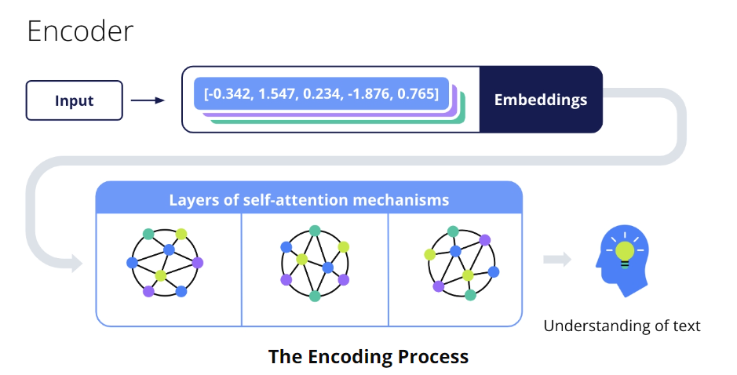

1. **Embeddings** - The numerical representations of words or tokens, typically in the form of vectors. Embeddings convert words into a format that can be processed by neural networks and other algorithms. They capture and quantify aspects of word meanings, their use in different contexts, and their syntactic roles.
2. **Self-Attention in Transformers** - This technique is used to calculate attention scores for each token, determining how much focus to put on other tokens in the sentence. It leads to a context-aware representation of each word.

# Encoders and Decoders

## **Encoders and Decoders**

In Transformer models, these are distinct components. The **encoder** processes the input text, converting it into numerical values known as embeddings. The **decoder** then uses these embeddings to generate output text.

### **Decoding Strategies**

* **Greedy Decoding** - Picks the most likely next word at each step. Efficient but can lead to suboptimal sequences.
* **Beam Search** - Tracks a number of possible sequences (beam width) to find a better sequence of words. It balances between the best local and overall choices.
* **Top-K Sampling** - Randomly picks the next word from the top K most likely candidates, introducing randomness and diversity.
* **Top-P (Nucleus) Sampling**: Chooses words from a set whose cumulative probability exceeds a threshold, focusing on high-probability options.

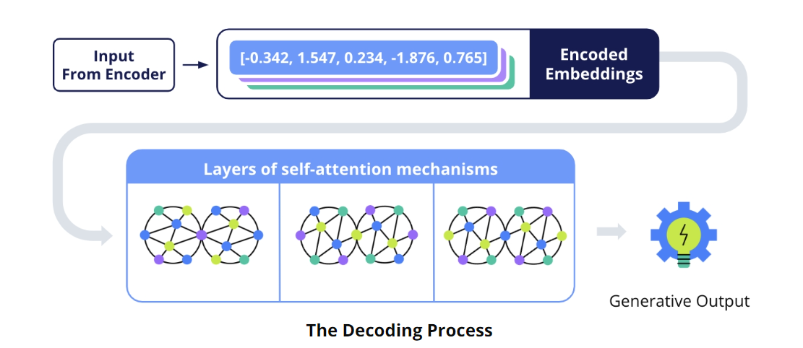

#### Temperature Setting

This model setting controls the randomness of token predictions. A higher temperature leads to more randomness, while a lower temperature makes the model more confident (less random) in its predictions.

# Accessing Foundation Models

In this exercise, you'll explore generative AI models available to you in Amazon Bedrock. Amazon Bedrock provides access to many open-source foundation models from leading AI companies along with a broad set of capabilities needed to build generative AI applications with security, privacy, and responsible AI.

Bedrock allows for more advanced customization of your data using techniques such as fine-tuning and Retrieval Augmented Generation (RAG) which you’ll learn more about later in this lesson., as well as image generation models.

Before you can try out these models, you'll have to set up access to them on the AWS platform.

Step 1: Go to Amazon Bedrock in the AWS Console

Launch the cloud gateway in your classroom, and open the AWS cloud console. Search for **Amazon Bedrock** using the search box at the top of the AWS console, and select it from the list of services.

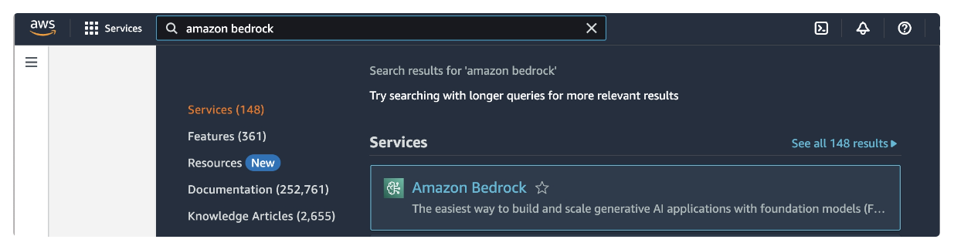

You might see a button to get started with Amazon Bedrock. Click on **Get Started** to be taken to the Amazon Bedrock interface.

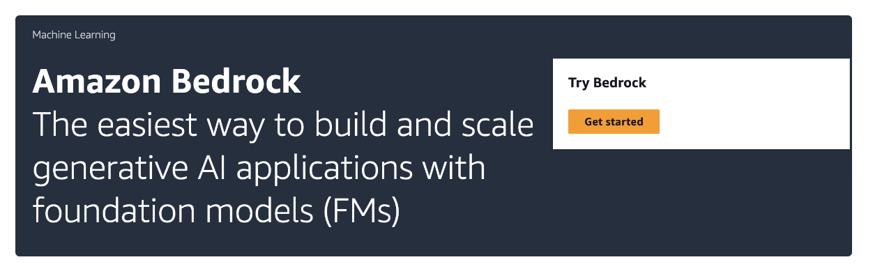 Step 2: Manage Model Access in Amazon Bedrock

Once you're in the Amazon Bedrock interface, look for the **Model Access** link on the bottom of the left side navigation panel in the Amazon Bedrock menu. Click on **Model Access.**

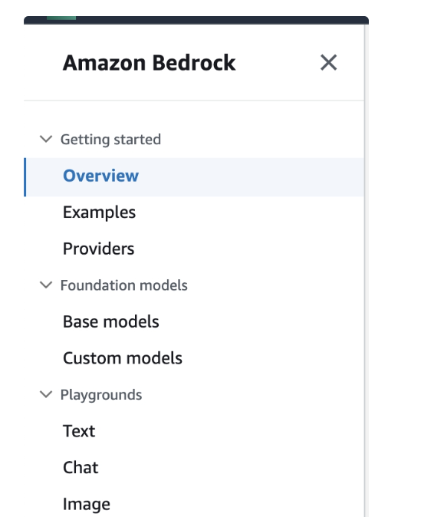

This page lists text, image, and embedding models. The modality lists whether the model is used for text, embedding, or images. Click on **Manage model access** button in the top right of the page.

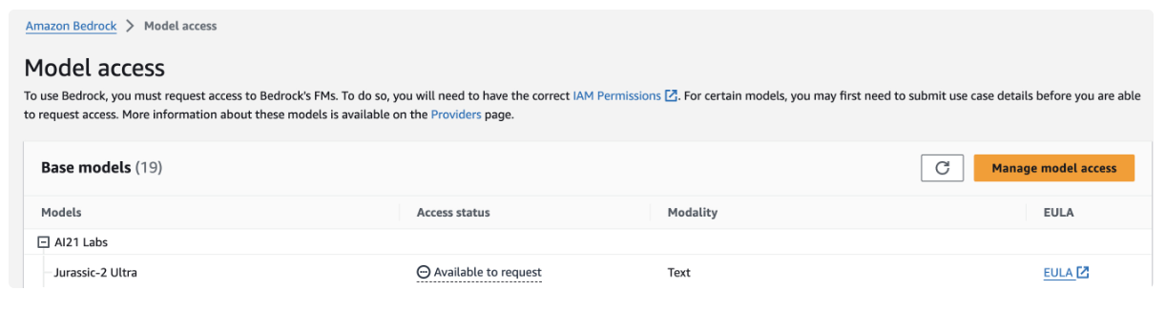

You'll see the same list of models, but now they have a check box next to them. Select the check box next to the following models:

* **Jurassic-2 Mid (under AI21 Labs)**
* **Llama 2 Chat 70B (under Meta)**



Select the **Save Changes** button in the lower right corner of the page. It may take several minutes to save changes to the Model access page.

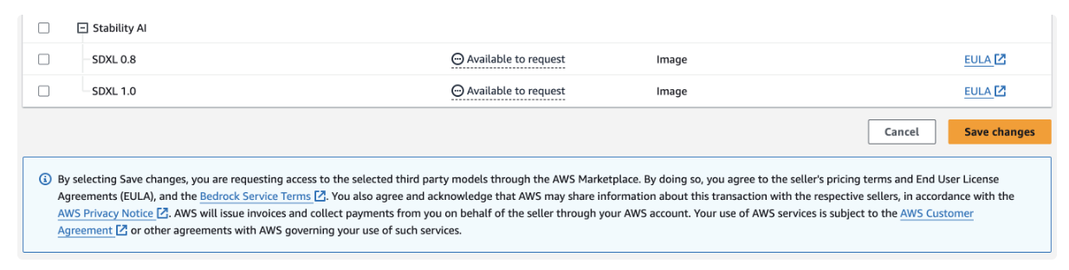

The Jurassic-2 Mid and Llama 2 Chat 70B models will now show as **Access granted** on the Model access page under Access status.

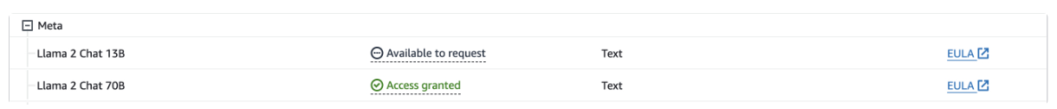

# Building LLMs with Code

### **Visualization and Code Implementation**

Tools like TensorBoard or Matplotlib in Python can visualize embeddings or attention scores. Code for NLP with transformer models often uses libraries like Hugging Face's transformers and deep learning frameworks like PyTorch or TensorFlow.

* Tokenization and embedding processes are handled by pre-built classes in NLP libraries.
* The transformer architecture applies self-attention and feed-forward neural networks to process embeddings.
* Visualization of embeddings or attention scores can provide insights into the model's processing.

These steps enable transformer models to understand nuances and context in language, facilitating complex tasks like translation, content generation, and conversation.

Understanding the code and the computational processes behind these models is key for those interested in NLP and AI development.

#### Understanding the Process

Let's take the sentence, "A young girl named Alice sits bored by a riverbank, …" and explore how a transformer model processes this text.

1. **Tokenization -** The sentence is broken into tokens. "Alice" is one token, while "riverbank" may be split into "river" and "bank".
2. # Tokenization using Hugging Face's Transformers
3. from transformers import AutoTokenizer
4. tokenizer = AutoTokenizer.from\_pretrained("gpt-2")
5. tokens = tokenizer.tokenize("A young girl named Alice sits bored by a riverbank...")
6. **Embedding -** Tokens are transformed into numerical vectors. For example, "Alice" becomes a vector like [-0.342, 1.547, 0.234, -1.876, 0.765].
7. # Embedding and Processing with a Transformer Model
8. from transformers import AutoModel
9. model = AutoModel.from\_pretrained("gpt-2")
10. inputs = tokenizer("A young girl named Alice sits bored by a riverbank...", *return\_tensors*="pt")
11. outputs = model(\*\*inputs)
12. last\_hidden\_states = outputs.last\_hidden\_state
13. **Self-Attention -** The model calculates attention scores for each token, understanding their importance in context.
14. **Layered Processing -** Multiple neural network layers process these embeddings, enhancing understanding at each step.
15. **Encoders and Decoders -** The encoder processes input text into embeddings, and the decoder generates output text, using strategies like Greedy Decoding or Beam Search.
16. # Visualization of Embeddings (Simplified Example)
17. import matplotlib.pyplot as plt
18. plt.imshow(last\_hidden\_states.detach().numpy()[0], *cmap*='viridis')
19. plt.colorbar()
20. plt.show()

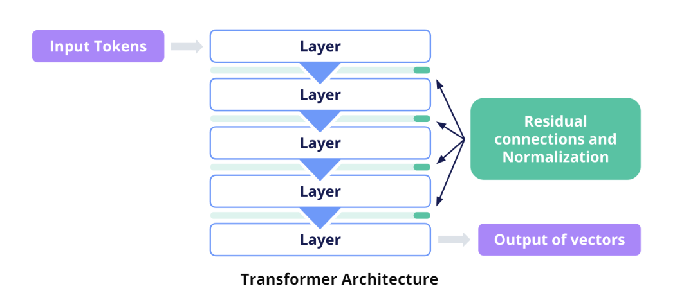

### **Transformer Models**

The core of a transformer model consists of multiple layers of self-attention and feed-forward neural networks. Each layer processes the input embeddings and passes its output to the next layer.

The actual processing involves complex mathematical operations, including self-attention mechanisms that allow each token to interact with every other token in the sequence. This is where the contextual understanding of language happens.

The final output from these layers is a set of vectors representing the input tokens in context.

* Python libraries such as Hugging Face's transformers handle tokenization and embedding.
* The transformer architecture's layered processing is managed by deep learning frameworks like PyTorch or TensorFlow.
* Visualization of embeddings or attention scores can be achieved using Python's Matplotlib.

# Storing LLM Knowledge

## **The Mechanism and Business Impact of Large Language Models**

In the advanced field of artificial intelligence, Large Language Models (LLMs) are notable for their complex system of storing and leveraging extensive knowledge. This process, crucial for AI-driven business strategies, combines technical ingenuity with practical applications.

### **Core Mechanism of LLMs**

* **Network of Parameters and Weights -** At the core of LLMs is a detailed network, similar to human brain synapses, where knowledge is encoded. Through comprehensive training, this network is refined, enabling the LLM to capture language subtleties, patterns, and complexities. Each parameter is a representation of a language element learned from training data, together forming an all-encompassing understanding of language.
* **Knowledge Storage** - LLMs store this knowledge meticulously in a binary format within their file structure, akin to a digital vault. These files, with extensions like .bin or .h5, are not readily interpretable but are integral to the LLM's functionality, encapsulating the culmination of its learning experience.

### **Is the knowledge always accurate, right, or correct?**

Sometimes, models generate information or content that isn't accurate or doesn't align with reality. This is referred to as "hallucinating".

Generative AI models don't "understand" content in the human sense; they predict the next word in a sequence or generate pixels in images based on probability and the patterns they've seen during training. Because of this, they can sometimes generate plausible-sounding but incorrect or nonsensical information, or add an extra arm or leg to an image of a human. This happens more often when your prompt (input) is ambiguous, the topic is outside the model's training data, or the question requires nuanced understanding or specialized knowledge.

**It's important to approach these models with a critical mind**, understand their limitations, and double-check information when accuracy is important in their output.

### **Utilization of Knowledge**

* **Prompt-Driven Activation** - The application of stored knowledge is triggered by prompts, acting as keys to unlock the model’s potential. Crafting effective prompts is crucial for accurate and contextually appropriate outputs.
* **Knowledge Application** - Once activated, LLMs analyze their parameters, applying learned insights to generate responses. In critical domains like legal or medical sectors, LLMs can incorporate real-time data, ensuring outputs are both linguistically coherent and factually accurate.

### **Business Implications**

In the modern business environment, LLMs transcend their role as mere data repositories. They actively interpret and generate language, turning extensive, unstructured data into actionable business insights. For professionals in various fields, leveraging LLMs' capabilities can significantly drive innovation, improve operational efficiency, and open new opportunities in an era dominated by AI technology. Understanding and effectively utilizing these models can be a transformative factor in business strategy and decision-making.

# Using pre-trained Large Language Models

## **Engaging with Large Language Models (LLMs)**

LLMs have emerged as versatile tools, offering a spectrum of interaction methods tailored to diverse applications in natural language processing. While text input remains the crux of these interactions, the modalities in which LLMs are engaged vary significantly, reflecting the evolving needs of users and the innovative scope of applications.

### **Direct Interaction**

At the simplest level, direct interaction with LLMs involves users inputting text for a variety of tasks, from content summarization to question answering and creative writing. This straightforward method forms the baseline of LLM engagement, showcasing their primary capability in processing and responding to textual data.

### **Versatility**

The versatility of LLMs extends beyond this direct text input, as they are increasingly integrated into various applications. In the realm of text editors, for instance, LLMs function behind the scenes, enhancing user experience through advanced features such as grammar correction or predictive typing. Here, the user's interaction is primarily with the application interface, while the LLM works subtly in the background, analyzing and responding to the user-generated text.

### **Using APIs**

For developers, LLMs offer a different mode of interaction through APIs. This method involves more complex engagements where the text input is part of larger request payloads, often accompanied by specific parameters and configurations. Such interactions enable customized processing by the LLM, allowing developers to create sophisticated, AI-driven tools and features.

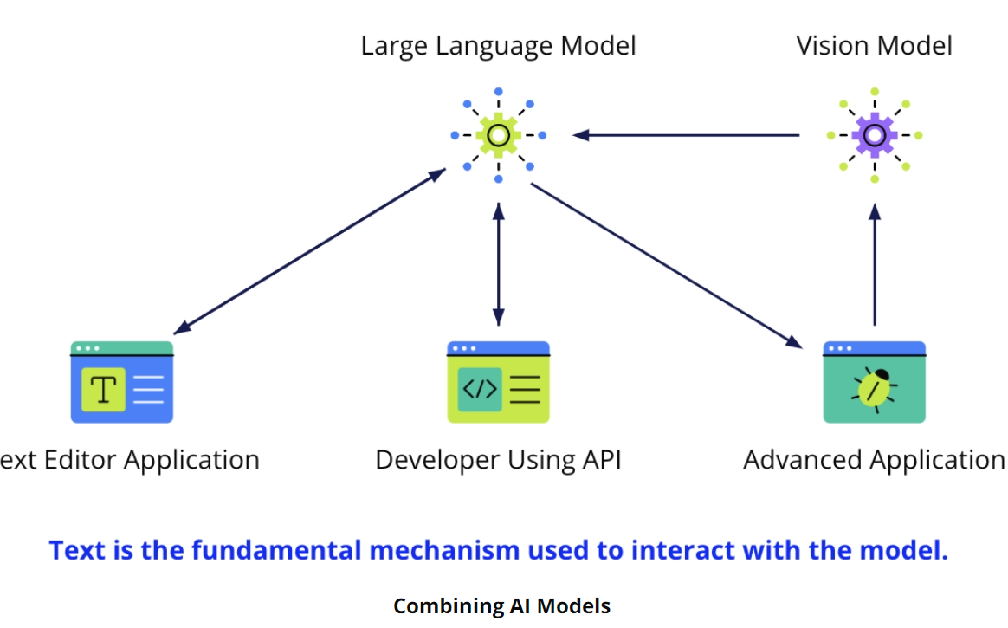

### **Combining AI Models**

In more advanced applications, LLMs are combined with other AI models, such as vision models that interpret non-textual data. An image described in text by a vision model, for instance, can be transformed into a captivating narrative by an LLM, exemplifying the model's ability to process and contextualize a wide range of information.

### **Key Terms**

* **Direct Text Input** - The primary method of user interaction with LLMs, involving straightforward text entry for processing.
* **Application Integration** - Embedding LLMs within user-facing software, where they enhance functionality and improve user experience.
* **API Interaction** - A method for developers to access LLM functionalities, offering customizable options for various applications.
* **Cross-Model Collaboration** - Combining LLMs with other AI models to process and contextualize a broader scope of data.

These diverse interaction methods highlight the adaptability of LLMs, making them invaluable across different sectors. From enhancing consumer software to empowering developers and bridging different AI technologies, LLMs stand as a testament to the innovative potential of modern artificial intelligence.

# Prompts and Prompt Engineering

## **Understanding Interaction through Prompt Engineering**

In the sophisticated field of artificial intelligence, Large Language Models (LLMs) operate on a fundamental principle: the generation of text is conditional upon the input they receive. This input, known as a prompt, is crucial in shaping the model's output, making prompt engineering an essential skill in leveraging LLMs for various tasks.

### **The Art and Science of Prompt Engineering**

* **Crafting Prompts** - Much like an engineer designs systems for specific functions, prompt engineering involves creating prompts that guide LLMs to achieve desired outcomes. It's a blend of understanding the model's interpretive abilities and creatively eliciting the best responses.
* **Importance of Context** - Context in prompts is vital. It not only guides the model's response but also helps in disambiguating meanings and maintaining coherence in the conversation or text generation.
* **Task Specificity** - LLMs are versatile and can perform a range of tasks. Through prompt engineering, users can direct the model to address specific requirements, whether it's generating text, answering questions, or solving problems.

### **Key Elements in Prompt Engineering**

* **Clarity** - Prompts should be clear and direct to avoid confusion, guiding the LLM toward the intended task.
* **Conciseness** - While context is important, prompts should also be concise to avoid overloading the model with unnecessary information.
* **Format** - Aligning the prompt with the model's training, such as using a question-answer format, can enhance the accuracy of the response.

# Types of Prompts

## **Types of Prompts**

**Zero-Shot Prompting** - Providing a language model with a task without any examples of how to perform it. The model relies on its pre-training to generate a response. Example: asking for a translation without providing previous examples.

**Few-Shot Prompting** - Giving the model a few examples of the task along with the prompt. These examples guide the model in understanding what's expected and demonstrate the desired output format.

**Chain of Thought Prompting** - A technique that involves guiding the model through a step-by-step reasoning process. It's useful for complex tasks that require logic or reasoning, like math problems or cause-and-effect questions.

### **Contextual Importance in LLMs**

* **Guiding Responses** - The context provided in prompts ensures that the responses are accurate, detailed, and relevant to the query.
* **Disambiguation** - It helps in clarifying ambiguous terms or phrases, enhancing the model's understanding.
* **Relevance** - The more relevant the context, the more on-point the LLM's output, avoiding generic or off-topic responses.

Effective prompt engineering is about striking a balance – providing enough context to guide the model while keeping the input focused and relevant. This approach enables users to harness the full potential of LLMs, turning them into powerful tools for a wide array of applications in business, research, and creative domains.

Different open-source LLMs have different numbers of parameters and are trained with different datasets and for different **tasks**:

* Question answering
* Categorization
* Summarization
* Domain Knowledge

Therefore, they'll give different answers to the same prompts. The Amazon Bedrock console playgrounds allow you to experiment with models and prompts and evaluate their output before using them. There are playgrounds for text, chat, and image models.

Within each playground, you can enter prompts and experiment with **inference parameters**. Prompts are one or more sentences of text that set up a scenario, question, or task for a model. We'll give you some prompts, and you can try some of your own!

Earlier in the lesson, you set up access to the following models in the **Accessing Foundation Models exercise**:

* Jurassic-2 Mid
* Llama Chat 70B

If you did not set up access to these models in the exercise, please go back and do so now before attempting this exercise.

#### Step 1: Set up Models in the Chat Playground

Launch the Cloud Gateway and open the AWS Console. Navigate to Amazon Bedrock using the search box in the top of the AWS console. Make sure you can access the Jurrasic-2 Mid and Llama Chat 70B models by choosing **Model Access** from the Amazon Bedrock left navigation menu. The list of models should show Access granted for these two models.

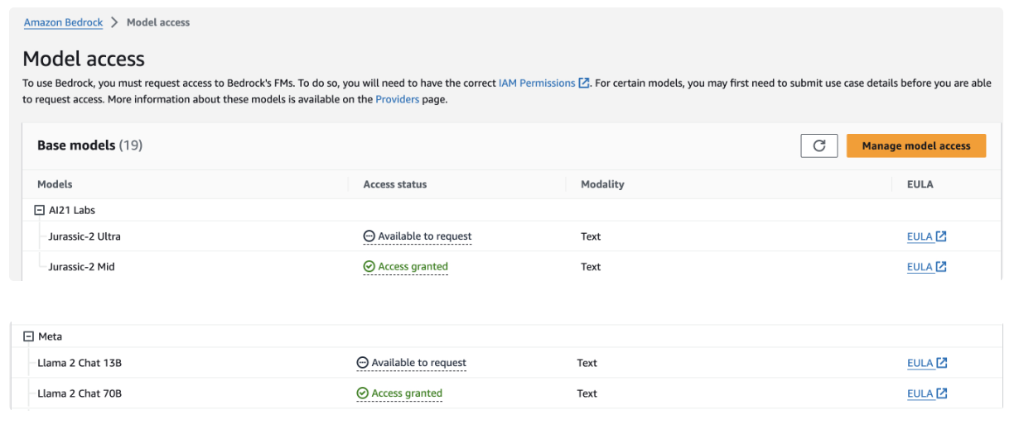

From the Amazon Bedrock left navigation panel, under Playgrounds, click on Chat to navigate to the Chat Playground.

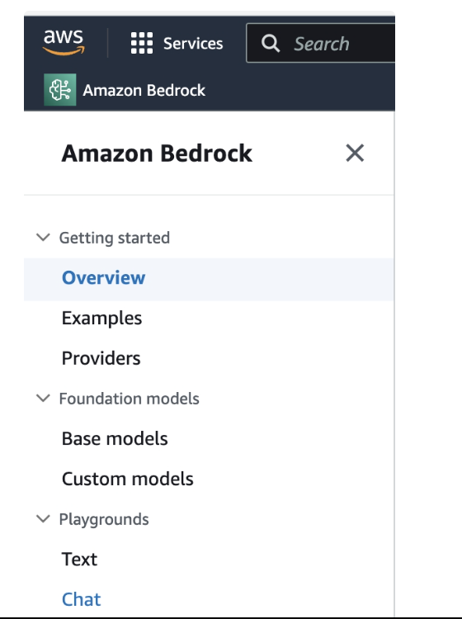

Click on **Select model** to open the Select model dialog box.

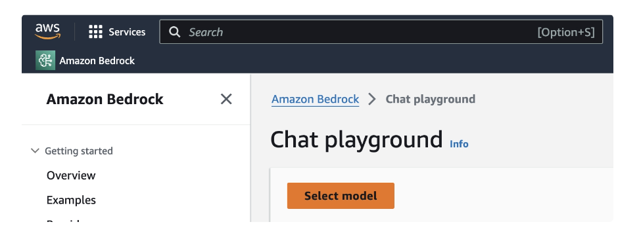

In the model selection dialog that opens, **choose the Jurassic-2 Mid model**, then click **Apply**

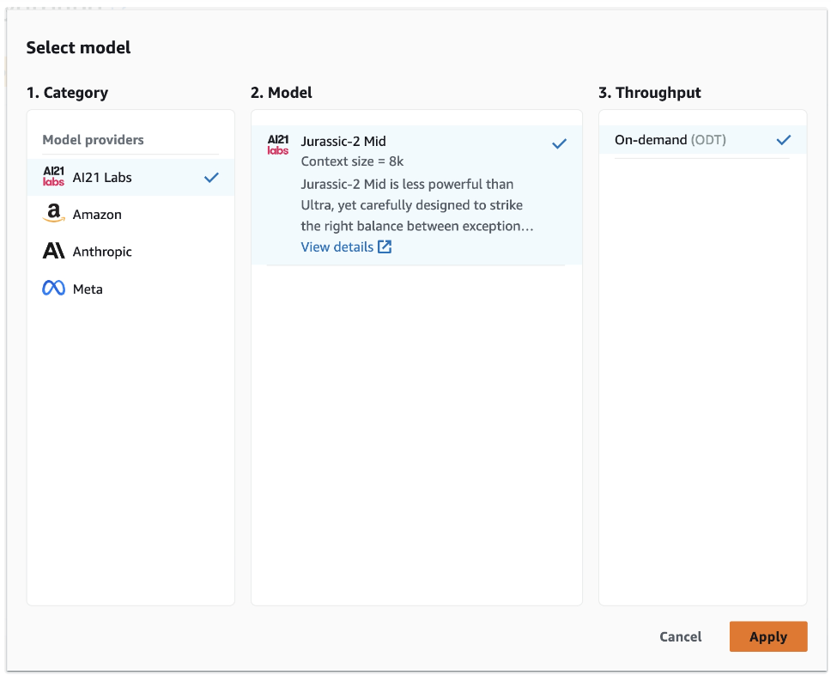

#### Step 2: Practice Some Prompts!

After you click Apply, you'll be in the playground interface, where you'll see a dialog box on the left, and inference parameters on the right. Try your first prompt. In the text box on the left of the **Run** button, **type the prompt "What is the capitol of France"** then click \*\*Run. \*\*

You'll see the model's response, highlighted in purple. Next, **type the prompt "What is Paris known for?**" and **click Run** again.

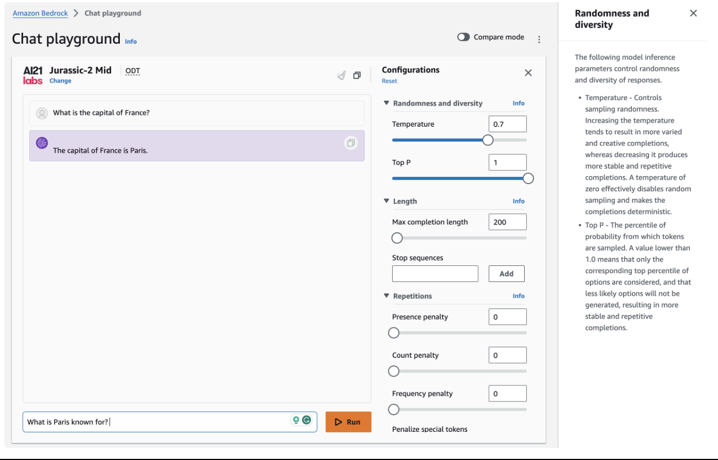

Now, change some of the inference parameters - Change the **temperature settings to 0 and 1** and **Max completion length to 3000**, and the **Top P sampling setting to 1 or 0**, and run more prompts. Here are some prompts to run, or think of your own. Try prompts for text completion, as well as instructions.

* (question answering) "What is Paris known for?"
* (text completion) "In Paris, a fish"
* (instruction) "Create a story about a fish in Paris"

Based on how the model was trained and its number of parameters, it may be better at some of these tasks than others. Some models are trained on text completion, while others are trained on question answering and instructions. Pay attention to how the model holds **context** during chat. Does it refer to previous output in the conversation correctly if you use words in your prompt like "it"?

*Note:*

*If the response violates the content moderation policy, Amazon Bedrock doesn't display it.*

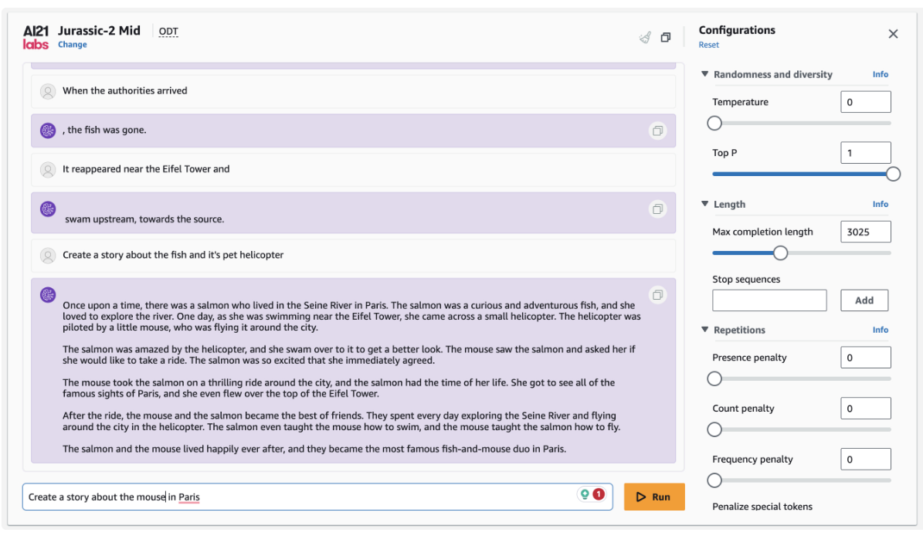

#### Step 3: Inspect Model Metrics

Every time you run a prompt, it costs a specific amount of money based on the model and the length of your prompt (tokens) and the amount of output the model generates (tokens). You can see this amount of money, how long the model took to respond (latency), and other metrics like token counts in the Model Metrics section below the prompt dialog.

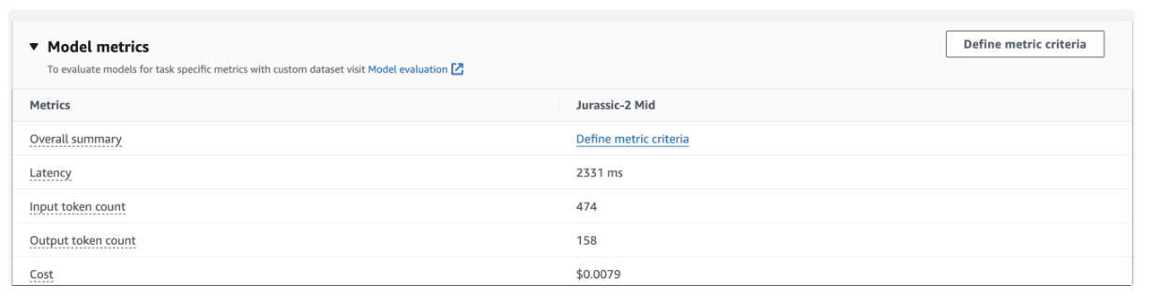

#### Step 4: Compare Models

Now, add another model to the chat playground, and run the same prompt against two models to compare their responses. This is a step toward model evaluation - testing models with the same prompts to evaluate their output on tasks like text summarization, question and answer, text classification, and open-ended text generation.

Toggle the **Compare Mode** setting in the top right of the Chat Playground to "on". Then, click the **Select Model** button to choose another model.

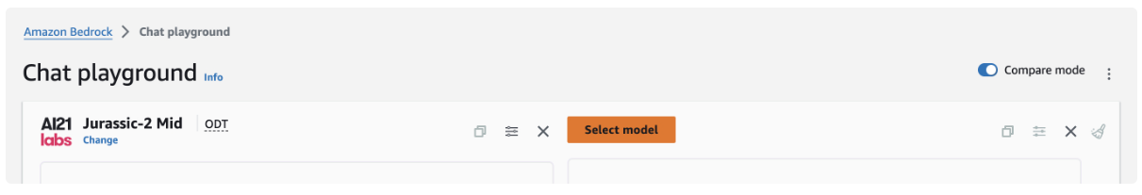

The model selection dialog opens, and this time you'll **choose the Meta Llama 2 Chat 70B model,** in order to compare it to the Jurassic-2 Mid model. When you're done choosing the Llama 2 Chat 70B model, click **Apply** in the bottom right corner of the Select Model dialog.

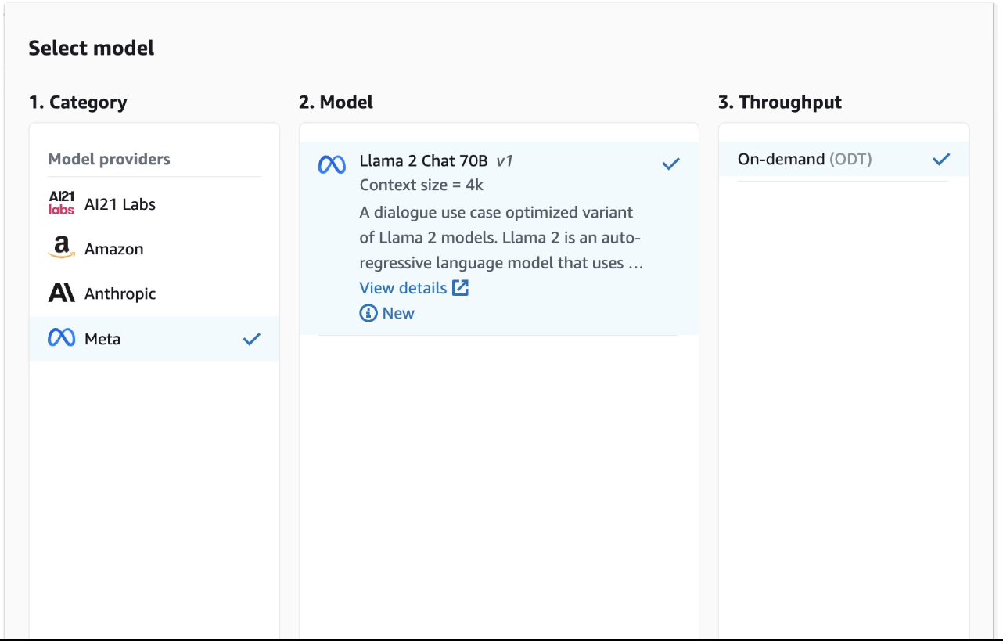

Now, when you run a prompt, you'll see 2 models and their responses. You can change the inference parameters of each model independently using the parameters icon to the right of each Model dialog

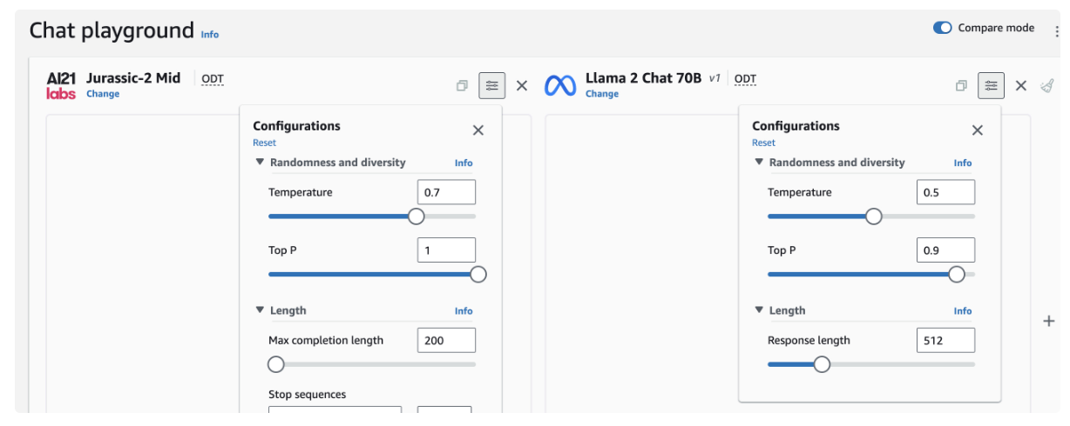

#### Step 5: Try a Chain-Of-Thought Prompt

A chain-of-thought prompt is a type of input given to a large language model (LLM) that guides it through a step-by-step reasoning process. Instead of simply asking a question or requesting a task, the prompt includes a logical sequence of thoughts or reasoning steps that lead to an answer or conclusion. This method is especially useful for complex queries where breaking down the problem helps the model generate more accurate and coherent responses.

**Chain-of-Thought Prompt:**

"I want to write a blog post about the basics of video editing for beginners. First, I should start with an introduction that explains why video editing is a valuable skill in today's digital world. Then, I need to outline the key steps in the video editing process, such as importing footage, cutting and arranging clips, adding transitions, working with audio, and applying effects and color correction. Each step should be explained in simple, accessible language. It's also important to suggest some beginner-friendly video editing software options, like Adobe Premiere Pro, Final Cut Pro, and more affordable or free alternatives like DaVinci Resolve and iMovie. Finally, I should wrap up the post with some encouraging words about practice and improvement over time, and possibly suggest some online resources or tutorials for further learning. What would be a good structure and content for such a blog post?"

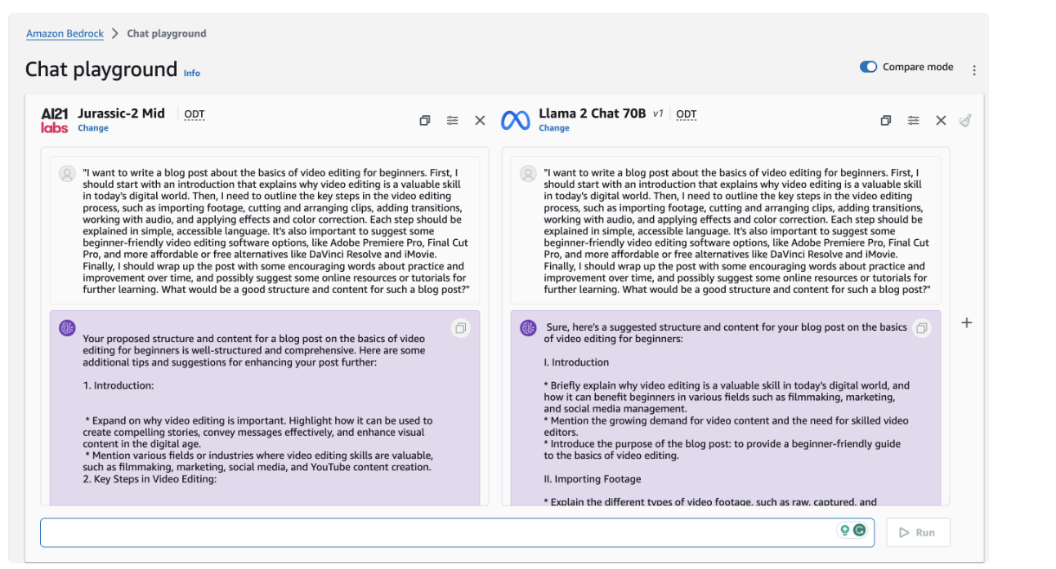

# Retrieval Augmented Generation (RAG)

## **Enhancing Understanding with Retrieval Augmented Generation (RAG) in NLP**

In the evolving landscape of Natural Language Processing (NLP), the integration of Retrieval Augmented Generation (RAG) marks a significant leap. This method synergizes the linguistic finesse of Large Language Models (LLMs) with the precision of external knowledge bases, crafting responses that are not only linguistically coherent but also factually enriched.

### **The Mechanism of RAG**

1. **Retrieval Step**
   * Upon receiving a prompt, the RAG system embarks on a quest for knowledge. It delves into vast datasets or specialized knowledge bases, seeking information that resonates with the prompt's essence.
   * Employing a trained retrieval model, it sifts through a multitude of documents, pinpointing those that shimmer with relevance and utility for the given context.
2. **Generation Step**
   * The journey doesn’t end with retrieval. The language model, equipped with the gleaned knowledge, weaves this information into its response fabric.
   * It's a harmonious blend – the innate understanding of language from the LLM's training interlaced with freshly acquired, specific insights from external sources. The outcome? A response that's not just articulate but informed and contextual.

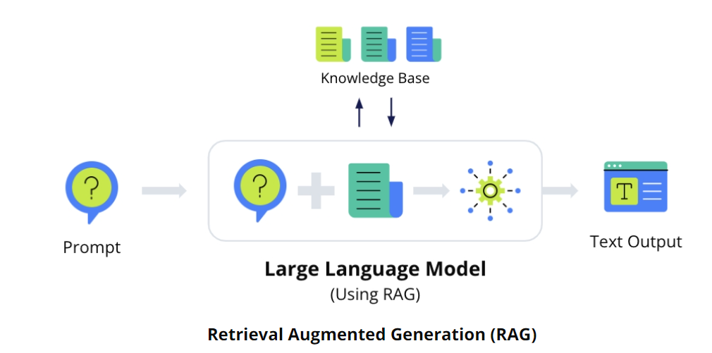

**The Art of Prompt Engineering in RAG**

* Here, the craft of prompt engineering ascends to a pivotal role. It's akin to setting the coordinates for a voyage – the prompt doesn't just ignite the generation process; it also steers the retrieval mechanism towards the most pertinent information.
* A meticulously engineered prompt is the compass that guides the RAG system through the vast seas of data, ensuring that the treasures it fetches are exactly what's needed to construct a response that hits the mark.

### **The Balance of Power and Responsibility**

* While RAG systems are potent tools in the arsenal of NLP, wielding them, especially in critical fields like medicine, calls for responsibility. The information they generate, while advanced and comprehensive, still requires the discerning eye of human validation.
* RAG systems are valuable in domains requiring accuracy and up-to-date information, like medicine.
* They can synthesize information from recent research papers and studies to generate informed content.
* In critical domains like medicine, it's essential to verify RAG-generated information against trusted sources.
* While RAG enhances content generation, careful use and validation are key to ensuring accuracy and reliability.

# Foundation Models

## **Foundation Models in Machine Learning**

Foundation models represent a significant shift in machine learning and artificial intelligence. They serve as versatile and powerful platforms for a variety of applications, thanks to their extensive training and generalization capabilities. Here's a concise overview of their key attributes:

1. **Scale** - These models are colossal in size, often encompassing billions of parameters, making them capable of learning from and processing enormous datasets.
2. **Generalization** - Their design enables them to generalize knowledge across different languages, tasks, and domains. This broad scope allows them to capture a vast array of information and nuances.
3. **Adaptability** - One of their standout features is adaptability. Foundation models can be fine-tuned with additional training to cater to specific tasks or requirements, enhancing their flexibility and utility in various applications.
4. **Capabilities** - They boast a range of capabilities across different modalities, such as text and images. This versatility makes them suitable for diverse applications like language translation, question-answering, content summarization, image recognition, and more.
5. **Shared Architecture** - A single foundation model can act as a base for developing numerous specialized models. This approach significantly reduces the resources and time required to develop new models for different tasks, as it eliminates the need to train a new model from the ground up for each specific application.

Examples of foundation models include BERT for natural language understanding, GPT-3 for generative text applications, and T5, which handles a range of text-based tasks. The concept extends beyond language models, encompassing any pre-trained model that offers a foundational platform for further specialized learning and application development.

# Fine-Tuning LLMs

## **Fine-Tuning Large Language Models (LLMs)**

Fine-tuning a large language model (LLM) effectively customizes it for specialized tasks, leveraging its broad learning capabilities to adapt to specific domains or industries. This process refines the model's expertise, making it highly useful for niche applications. Let’s break down the key stages and outcomes of this process:

1. **Pre-Trained Model** - The foundation of fine-tuning is a model that has already been trained on a vast corpus of general text data. This extensive pre-training equips the model with a wide-ranging understanding of language.
2. **Specialized Dataset Preparation** - The specific task or domain dictates the dataset for fine-tuning. For instance, legal documents and texts are prepared for fine-tuning a model for legal applications.
3. **Fine-Tuning Process** - The model undergoes additional training on this specialized dataset. This stage involves adjusting the model's weights and parameters to align more closely with the domain-specific language, style, and content. The learning rate during fine-tuning is typically lower, allowing for subtle yet effective modifications.
4. **Gaining Task-Specific Abilities** - Post fine-tuning, the model becomes more proficient in handling the particularities of the new domain. This includes a better grasp of specific terminologies, writing styles, and types of queries or tasks pertinent to the dataset it was fine-tuned on.
5. **Enhanced Performance in Specialized Tasks** - The fine-tuned model now exhibits improved performance and accuracy in tasks related to its specialized training. This makes it a valuable asset for professionals within that specific field, such as legal experts, medical practitioners, or chemical engineers, depending on the focus of fine-tuning.
6. **Customization for Organizational Needs** - Organizations can leverage fine-tuning to tailor LLMs to their unique requirements. This could range from enhancing customer service interactions to generating content that aligns with a brand’s voice or providing technical support in a specific industry.

In essence, fine-tuning transforms a generalist LLM into a specialist tool, extending its utility beyond general applications to more focused, domain-specific tasks. This process exemplifies the flexibility and adaptability of LLMs, showcasing their potential to provide bespoke solutions across various sectors.

# Explore Fine-Tuning Code

In this exercise, you'll inspect the code for fine-tuning a large language model, and answer questions about it.

The code below fine-tunes a model to be an "expert" on Amazon SEC filings from 2021-2022. The dataset used for fine-tuning is one large text file, containing the text of the SEC filings, the text in the file looks like this:

"This report includes estimates, projections, statements relating to our

business plans, objectives, and expected operating results that are “forward-

looking statements” within the meaning of the Private Securities Litigation

Reform Act of 1995, Section 27A of the Securities Act of 1933, and Section 21E

of the Securities Exchange Act of 1934. Forward-looking statements may appear

throughout this report, including the following sections...."

#### Fine-Tuning Code

The code below loads the dataset of the SEC filings text file from an AWS S3 storage bucket. Then the dataset is used to fine-tune the open-source Falcon 7B text generation large language model for **domain adaptation**.

* It uses the dataset of financial text from SEC filings to fine-tune huggingface-llm-falcon-7b-bf16 for financial applications.

Here are the requirements for the train and validation data.

* Input: A train and an optional validation directory. Each directory contains a CSV/JSON/TXT file.
* For CSV/JSON files, the train or validation data is used from the column called 'text' or the first column if no column called 'text' is found.
* The number of files under train and validation (if provided) should equal to one.
* Output: A trained model that can be deployed for text generation tasks with specialized domain knowledge.
* # Idenfity the foundation model to fine-tune
* model\_id = "huggingface-llm-falcon-7b-bf16"
* # The training data of SEC filing of Amazon has been pre-saved in the S3 bucket.
* from sagemaker.jumpstart.utils import get\_jumpstart\_content\_bucket
* # Sample training data is available in this bucket
* data\_bucket = get\_jumpstart\_content\_bucket(aws\_region)
* data\_prefix = "training-datasets/sec\_data"
* training\_dataset\_s3\_path = *f*"s3://{data\_bucket}/{data\_prefix}/train/"
* validation\_dataset\_s3\_path = *f*"s3://{data\_bucket}/{data\_prefix}/validation/"
* #Prepare training parameters
* from sagemaker import hyperparameters
* my\_hyperparameters = hyperparameters.retrieve\_default(
* *model\_id*=model\_id, *model\_version*=model\_version
* )
* my\_hyperparameters["epoch"] = "3"
* my\_hyperparameters["per\_device\_train\_batch\_size"] = "2"
* my\_hyperparameters["instruction\_tuned"] = "False"
* print(my\_hyperparameters)
* Validate hyperparameters
* hyperparameters.validate(
* *model\_id*=model\_id, *model\_version*=model\_version, *hyperparameters*=my\_hyperparameters
* )
* # Starting training
* from sagemaker.jumpstart.estimator import JumpStartEstimator
* domain\_adaptation\_estimator = JumpStartEstimator(
* *model\_id*=model\_id,
* *hyperparameters*=my\_hyperparameters,
* *instance\_type*="ml.p3dn.24xlarge",
* )
* domain\_adaptation\_estimator.fit(
* {"train": training\_dataset\_s3\_path, "validation": validation\_dataset\_s3\_path}, *logs*=True
* )
* Extract Training performance metrics. Performance metrics such as training loss and validation accuracy/loss can be accessed through cloudwatch while the training. We can also fetch these metrics and analyze them within the notebook
* from sagemaker import TrainingJobAnalytics
* training\_job\_name = domain\_adaptation\_estimator.latest\_training\_job.job\_name
* df = TrainingJobAnalytics(*training\_job\_name*=training\_job\_name).dataframe()
* df.head(10)
* # Deploying inference endpoints
* # We deploy the domain-adaptation fine-tuned and pretrained models separately, and compare their performances.
* # We first deploy the domain-adaptation fine-tuned model.
* domain\_adaptation\_predictor = domain\_adaptation\_estimator.deploy()
* Next, we deploy the pre-trained huggingface-llm-falcon-7b-bf16.
* my\_model = JumpStartModel(*model\_id*=model\_id)
* pretrained\_predictor = my\_model.deploy()
* # Running inference queries and compare model performances
* parameters = {
* "max\_new\_tokens": 300,
* "top\_k": 50,
* "top\_p": 0.8,
* "do\_sample": True,
* "temperature": 1,
* }
* *def* generate\_response(*endpoint\_name*, *text*):
* payload = {"inputs": *f*"{*text*}:", "parameters": parameters}
* query\_response = query\_endpoint\_with\_json\_payload(
* json.dumps(payload).encode("utf-8"), *endpoint\_name*=*endpoint\_name*
* )
* generated\_texts = parse\_response(query\_response)
* print(*f*"Response: {generated\_texts}{newline}")
* test\_paragraph\_domain\_adaption = [
* "This Form 10-K report shows that",
* "We serve consumers through",
* "Our vision is",
* ]
* for paragraph in test\_paragraph\_domain\_adaption:
* print("-" \* 80)
* print(paragraph)
* print("-" \* 80)
* print(*f*"{bold}pre-trained{unbold}")
* generate\_response(pretrained\_predictor.endpoint\_name, paragraph)
* print(*f*"{bold}fine-tuned{unbold}")
* generate\_response(domain\_adaptation\_predictor.endpoint\_name, paragraph)
* # The fine-tuned model starts to generate responses that are more specific to the domain of fine-tuning data which is relating to SEC report of Amazon.
* # Clean up the endpoint
* # Delete the SageMaker endpoint
* pretrained\_predictor.delete\_model()
* pretrained\_predictor.delete\_endpoint()
* domain\_adaptation\_predictor.delete\_model()
* domain\_adaptation\_predictor.delete\_endpoint()

# Generative AI in Real World Applications

## **AI in Our World - Opportunities and Responsibilities**

In the dynamic world of Artificial Intelligence (AI), we find ourselves at a crossroads of **opportunity and responsibility**. Imagine AI systems filtering job applicants and empowering musicians with endless creative possibilities. This contrast shows AI's diverse impact on our lives.

### **AI's Positive Impact**

AI has made significant strides in **healthcare**, **environmental conservation**, and **cultural preservation**. Its capabilities range from **diagnosing diseases** to **predicting natural disasters** and **protecting endangered species and languages**. These achievements highlight AI's potential to better human and environmental health, especially when guided by ethical practices.

### **Challenges in AI**

Despite its advancements, AI faces significant challenges. Issues of **racial bias in facial recognition**, **gender bias in medical tools**, and **accent bias in voice recognition** illustrate the need for fairness and inclusivity. These challenges emphasize the importance of developing AI systems responsibly.

### **The Path to Responsible AI**

Key elements in responsible AI development include:

* **Ethical Principles** - Upholding human rights, equity, privacy, and fairness.
* **Understanding AI's Limitations** - Recognizing its probabilistic nature and the need for human interpretation.
* **Data and Team Diversity** - Ensuring unbiased data and diverse development teams.
* **Continuous Improvement** - Maintaining ongoing validation and feedback mechanisms.

### **AWS's Role**

AWS provides tools and resources for the responsible development of AI systems, which we'll explore in this lesson. The focus is on leveraging generative AI's benefits while addressing its challenges.

# Impact on Creativity and Content Generation

## **Balancing Creativity and Ethics**

In today's business landscape, generative AI is emerging as a powerhouse of creativity and efficiency. This technology, capable of producing diverse forms of artistic and creative outputs, is reshaping industries and redefining the boundaries of innovation. Let’s delve into its implications and ethical considerations.

### **Widening Creative Horizons**

Generative AI democratizes the creative process, enabling individuals and businesses to produce a wide array of content, from visuals and music to writing and game design. It opens up new avenues for those without traditional training, particularly in sectors like marketing, advertising, and design.

### **Enhancing Efficiency**

By rapidly generating initial concepts, designs, or prototypes, generative AI accelerates the ideation process. This efficiency is a boon for businesses looking to stay ahead in fast-paced industries.

### **Ethical and Creative Challenges**

While generative AI offers numerous advantages, it also presents ethical and creative challenges:

* **Originality and Authorship** - Differentiating between AI-generated and human-created content raises questions about the authenticity and originality of creative works.
* **Impact on Creative Jobs** - The potential for AI to replicate or outpace human creativity poses a risk to traditional creative roles, potentially leading to job displacement.
* **Market Saturation** - The influx of AI-generated content could overshadow human creativity, making it harder for traditional artists to compete.

### **Navigating the Future**

To effectively harness generative AI while maintaining ethical standards, businesses need to:

* **Adopt Collaborative Approaches** - Combining AI-generated initial concepts with human expertise ensures a balance between innovation and authentic creativity.
* **Maintain Transparency** - Disclosing the use of AI in creative processes helps manage consumer expectations and maintains trust.
* **Foster Ethical Practices** - Implementing guidelines to respect intellectual property and preserve the value of human-driven creation is essential.

In conclusion, Generative AI holds tremendous potential for businesses in creative fields, but it's crucial to navigate its implementation thoughtfully. Balancing innovation with the preservation of human creativity and adhering to ethical standards is key to leveraging its benefits while addressing the challenges it presents.

# Demo: Image Generation

## **Image Generation with Generative AI**

In the demo above, we use **Bedrock Playgrounds** and **Stable Diffusion XL** to generate images using an LLM.

* The **Stable Diffusion** model is specifically designed for image generation using text prompts.
* The **seed**, shown in configuration settings, determines the starting point of the generative process.
* Using the same seed with the same prompt results in the generation of the exact same image.
* Changing the seed while keeping the prompt the same produces different images.

The Stable Diffusion model is **deterministic** and it will consistently produce the same output (image) for a given input (text prompt) and seed combination.

# **Promotional Imagery App**

## **Exercise: Promotional Image Generation with PartyRock**

In this exercise, you will create a simple, business-relevant app that generates custom promotional images using **[PartyRock(opens in a new tab)](https://partyrock.aws/?utm_source=udacity&utm_medium=course&utm_campaign=introtogenai" \t "_blank)**, an Amazon Bedrock Playground.

### **PartyRock**

PartyRock is a user-friendly platform designed as a no-code option for the creation of generative AI apps. You can experiment with generative AI through writing prompts (instructions for models), and image generation in a web-based interface.

[**PartyRock(opens in a new tab)**](https://partyrock.aws/?utm_source=udacity&utm_medium=course&utm_campaign=introtogenai) is currently accessible without the need for an AWS account or credit card.

***Note: use a personal account to access PartyRock, do not use the "Launch Cloud Gateway" account to access PartyRock. You will not be able to access PartyRock from the AWS credentials used when you launch the Udacity cloud gateway. PartyRock is free to use.***

### **Exercise Tasks**

1. **Concept Selection** - choose a simple business concept for your app and indicate the type of promotional images you need. For example:
   * A business selling smart home devices may need an app to create images depicting everyday life enhanced by smart home technology.
   * A medical office needs to illustrate the accessibility and convenience of its telemedicine services and needs an app to generate images that show patients engaging in virtual consultations with healthcare professionals.
2. **Use** **[PartyRock(opens in a new tab)](https://partyrock.aws/?utm_source=udacity&utm_medium=course&utm_campaign=introtogenai" \t "_blank)** - create an app focused on generating promotional images for your selected business.
   * Create a free account and user name.
   * Experiment with text-based prompts to specify the type of app you want to generate.

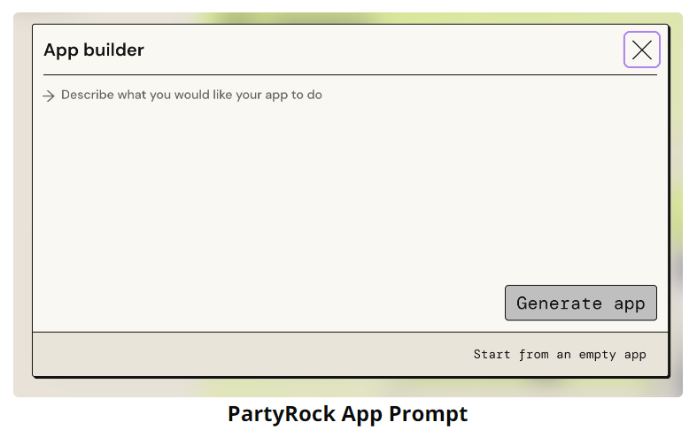

1. **Interact with Your App**
   * PartyRock will generate an app based on your previous prompt
   * In the *User Input* section of the app, enter your business-specific need.

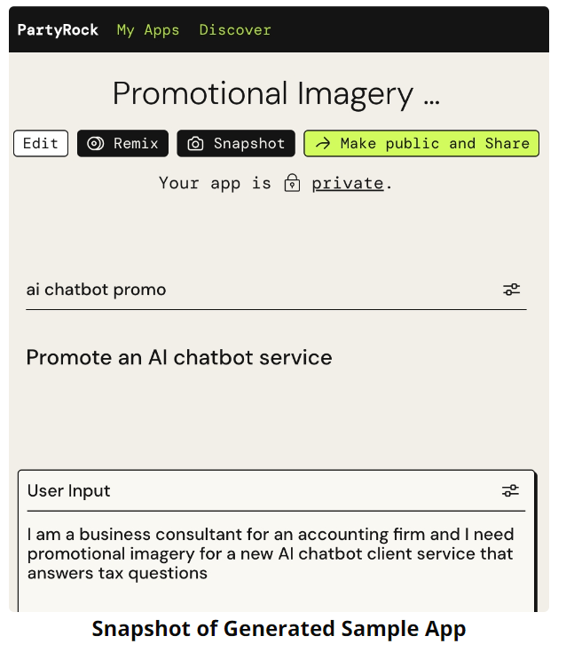

1. **Image Generation**
   * Generate at least one promotional image using your app.
   * Explore how different prompts affect the output.

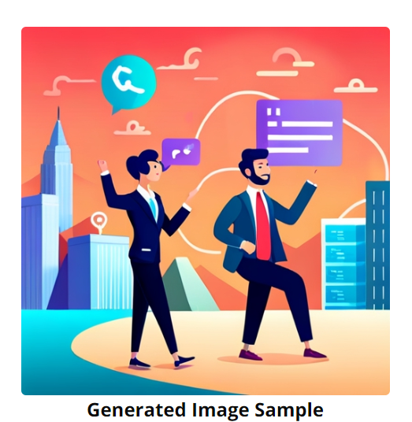

# Generative AI’s Impact on Society

## **A Catalyst for Accessibility and Economic Change**

Generative AI is transforming the landscape of accessibility and economic development. Its impact spans across various industries, creating both opportunities and challenges. Let’s explore how generative AI is revolutionizing accessibility and driving economic growth, alongside the ethical considerations it brings.

### **Transforming Accessibility**

1. **Text-to-Speech (TTS) Technology** - AI has refined TTS, turning text into remarkably human-like speech. This technology is life-changing for individuals with visual impairments or reading difficulties, enabling them to 'hear' text from images or videos.
2. **Language Translation** - AI’s translation capabilities bridge communication gaps, fostering global interaction and inclusivity for those with hearing challenges through AI-generated captions and subtitles.
3. **Personalized Assistive Devices** - generative AI can create synthetic datasets to train AI systems, enhancing their predictive capabilities. This leads to more personalized and effective assistive technologies.

### **Economic Impact**

1. **Job Creation** - AI is creating new roles in data science, AI ethics, and machine learning engineering. It's opening niches in creative industries like AI-assisted design, music production, and content creation, particularly in gaming, entertainment, and marketing.
2. **Boosting Efficiency and Innovation** - AI aids small businesses and entrepreneurs with cost-effective tools for content creation and market analysis. Its predictive capabilities expedite research and development cycles, improving productivity.
3. **New Markets and Demand** - AI-driven accessibility tools are stimulating investment and job creation in the tech sector, fostering economic growth.

# Challenges and Disputions

### **Challenges and Disruptions**

1. **Industry Disruption** - AI's ability to generate content can saturate markets, potentially overshadowing human-created works. In journalism, automated news-writing bots pose a threat to the future of human reporters.
2. **Job Displacement** - Automation may lead to job losses in sectors reliant on repetitive tasks. The pace of AI advancement might create a skills gap, affecting industries like manufacturing and logistics.
3. **Economic Inequality** - The uneven displacement across sectors and geographies could exacerbate economic inequalities.

### **Navigating the Future**

To balance AI's benefits with its challenges, a concerted effort is needed:

* **Upskilling and Education** - Governments and educational institutions must focus on preparing the workforce for an AI-centric economy, emphasizing the augmentation of human work by AI.
* **Ethical AI Frameworks and Policies** - Developing policies and ethical guidelines is crucial to ensure AI's responsible use and to mitigate job displacement.
* **Inclusive Growth** - The focus should be on ensuring that AI serves as a tool for empowerment and inclusion, not exclusion.

While generative AI is a potent force for accessibility and economic development. Its implementation needs to be guided thoughtfully to harness its benefits while addressing potential challenges. With proactive strategies, generative AI can be a tool for positive societal change.

# Responsible Use of Artificial Intelligence

## **Navigating the Complexities: Ethical Use, Education, and Inclusivity**

Generative AI is reshaping our digital world, offering incredible opportunities but also posing significant challenges. From facial recognition in public spaces to deepfakes, the implications of this technology touch on privacy, ethics, and societal norms. Let's explore these complexities and how we can navigate them responsibly.

### **Ethical Use and Challenges**

1. **Facial Recognition and Privacy** - The use of AI in public spaces for safety can conflict with personal privacy rights and raise issues of misidentification.
2. **Deepfakes and Misinformation** - AI-generated images and videos (deepfakes) blur the line between reality and fabrication, posing risks for misinformation and manipulation of public opinion.

### **Education and Awareness**

1. **User Awareness and Education** - Educating users about the capabilities and limitations of AI technologies is critical. This includes understanding the predictive nature of machine learning and recognizing AI-generated content.
2. **Public Awareness Campaigns** - Initiatives like the "Deepfake Education Initiative" and university courses on AI ethics are vital in fostering digital literacy and critical evaluation of AI content.
3. **AWS's Role in Education** - AWS partners with organizations to educate and guide policy development for responsible AI systems, offering tools to build unbiased and transparent AI models.

### **Fostering an Inclusive AI Environment**

1. **Inclusive Development Teams** - Diverse teams are essential in mitigating AI biases and ensuring fairness in outcomes.
2. **AI for All** - AI systems should be accessible to various languages, cultures, and abilities, promoting inclusivity and empowerment.
3. **Guardrails for Ethical AI** - Implementing detailed documentation, warnings, and technical restrictions can prevent misuse and align AI use with human rights and fairness principles.

### **Legal and Policy Frameworks**

1. **Legislative Action** - Laws against creating or distributing deepfakes and other manipulative AI content help govern responsible use.
2. **Media and Journalism Initiatives** - Newsrooms and social media platforms are employing tools and policies to detect and manage deepfake content.

# **Implementing Responsible Use**

The responsible use of AI encompasses leveraging and creating tools that address several overarching themes:

1. **Ethical Considerations and Privacy** - AI technologies like facial recognition raise critical ethical questions regarding privacy and surveillance. The challenge is to balance the benefits for public safety with the risks of privacy invasion or misidentification.
2. **Responsible and Inclusive Use of AI** - This theme stresses the necessity for AI to be developed and used responsibly and inclusively. It involves a collaborative effort from developers, users, educators, policymakers, and society. Inclusivity ensures that AI technologies are accessible and beneficial to diverse groups, avoiding bias and discrimination.
3. **User Education and Awareness** - Educating users about the capabilities and limitations of AI is crucial. This includes awareness of the predictive nature of machine learning, the potential for errors, and the correct application of technologies. It also involves teaching users how to critically evaluate AI-generated content and recognizing signs of AI involvement, such as inconsistencies or lack of depth.
4. **Oversight and Human Involvement** - Human oversight is essential, especially in areas impacting civil liberties or human rights. Training for human reviewers and understanding the output of AI systems are necessary to ensure that AI applications are fair, ethical, and effective.
5. **Transparency and Trust in AI** - Establishing trust in AI systems requires transparency in how these systems function, their potential for error, and the necessity of human oversight. Initiatives like digital literacy programs and public education campaigns about AI technologies, including deep fakes, play a vital role in building this trust.

Tools and initiatives like AWS's partnerships with organizations such as the [**Responsible AI Institute(opens in a new tab)**](https://www.responsible.ai/), the [**United Nations(opens in a new tab)**](https://www.aboutamazon.com/news/aws/aws-un-summit-generative-ai/), and the [**Organization for Economic Cooperation and Development(opens in a new tab)**](https://oecd.ai/en/) are crucial in achieving these goals. They provide resources for building unbiased and transparent AI models, emphasizing the importance of guiding AI development in a responsible, inclusive, and ethical manner.

# A Hospital Case Study

## **The Dilemma at HealthTech General**

HealthTech General, a semi-rural hospital, has recently integrated generative AI into its healthcare system. While this technology has brought significant advancements, it also presents a unique set of challenges.

### **The Scenario**

HealthTech General implemented a generative AI system designed to enhance patient treatment and diagnostics. Dr. Emily Johnson, a leading oncologist at the hospital, has been closely involved with this integration. She observes that while the AI system offers remarkably accurate diagnostic suggestions, it sometimes overlooks the nuances of rare cases that are not well-represented in the training data.

Dr. Johnson encountered a specific case with a patient, Mr. Smith, who exhibited symptoms that didn't entirely align with the common patterns of known illnesses. The AI system suggested a standard treatment plan, but Dr. Johnson suspected a rare condition that the AI hadn't considered.

### **The Problem**

The dilemma facing Dr. Johnson and HealthTech General is how to effectively integrate AI's suggestions while ensuring that rare and complex cases are not oversimplified or misdiagnosed. They need to find a balance between leveraging AI's efficiency and maintaining the essential human element in healthcare.

# Bias and Fairness in AI Systems

## **Understanding and Mitigating Bias in AI Systems**

The concept of bias in AI is crucial to understand for responsible AI development. Bias occurs when AI systems make unfair or prejudiced decisions, often influenced by skewed or unrepresentative training data. Let's explore the nature of bias in AI, its impacts, and strategies for mitigation.

### **Defining Bias and Its Impact**

Comparable to a soccer coach favoring speed over other skills, **AI bias** happens when a system makes decisions based on an unbalanced view of information. Bias affects model performance significantly. For instance, an autonomous car trained on limited data may struggle in diverse traffic scenarios, leading to unreliable performance.

Fair and unbiased AI models require training on diverse datasets.

### **Mitigation Strategies and Tools**

* **Dataset Diversity and Testing** - Curate representative datasets and continuously test and update models for fairness.
* **Statistical Analysis and Expert Review** - Analyze data distribution and consult domain experts for potential biases.
* **Bias Auditing Frameworks** - Utilize structured approaches and tools to identify biases in datasets.
* **Algorithm Auditing for Fairness** - Implement fairness constraints in learning algorithms, such as in credit scoring systems.
* **Interpretability and Explainability** - Use tools to understand decision-making processes in AI models, identifying inherent biases.

# Detect and Address Bias

## **Detecting and Addressing Bias**

* AWS offers various tools to support these strategies, ensuring responsible AI development:
  + **Mitigating Human Error** - Use knowledgeable annotators and accuracy checks.
  + **Fairness Metrics** - Establish and measure system performance across demographic groups.
  + **Independent Bias Testing** - Engage external parties for unbiased system assessments.
  + **Responsive Action Plans** - Address detected biases through data collection adjustments, algorithm modifications, or model retraining.
  + **User Feedback Mechanisms** - Allow real-world performance assessments to gather insights on diverse user experiences.

### **Key Takeaways**

* Minimizing bias and maximizing fairness in AI models leads to more equitable and effective systems.
* The goal is an AI that is not only efficient but also ethically committed to fairness and inclusivity.
* Continuous improvement and conscientious practices are essential to prevent AI systems from perpetuating or creating inequities.

# Identifying Bias in Datasets

## **Identifying Bias in AI Training Data**

You are part of a data science team at an AI company, "FairTech AI," which specializes in creating AI models for various industries. Your current project involves developing an AI system for a healthcare provider to predict patient health risks. The company is committed to ensuring that the AI system is unbiased and equitable.

### **The Task**

Your team has received a dataset to train the AI model. However, there are concerns that this dataset may contain biases that could lead to unfair or prejudiced predictions. Your task is to scrutinize the dataset and identify any labels or data points that might indicate bias.

### **Dataset Sample**

The dataset comprises patient records with various attributes. Here's a sample of the data:

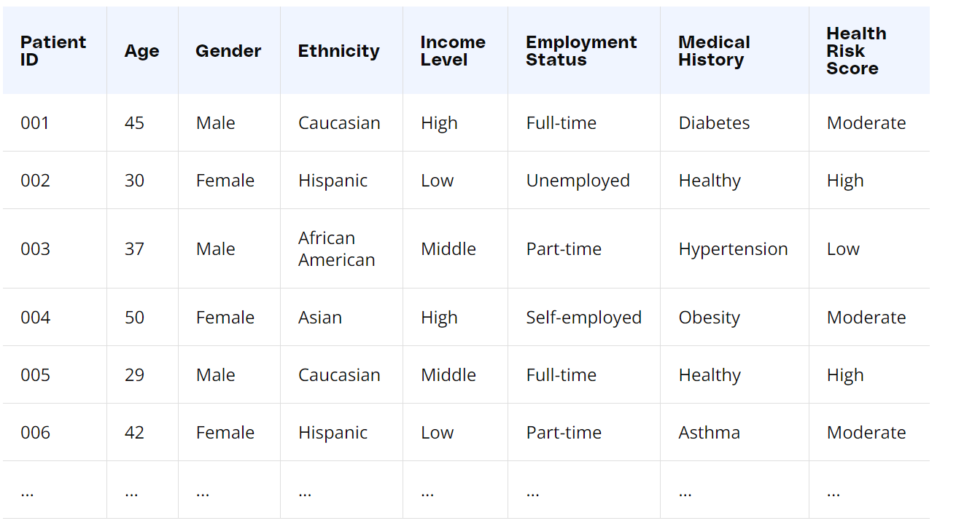

(Note: This is a simplified representation for educational purposes. An actual dataset would contain more records and potentially more complex attributes.)

### **Instructions**

* Review the sample dataset.
* Identify any labels or data points that might be indicative of bias.
* Consider aspects such as representation across different demographic groups and the potential for stereotypes or assumptions to influence the "Health Risk Score."

# Building Ethical AI Systems

## **Ethical Frameworks, Inclusivity, and Responsible Development**

The advancement of artificial intelligence (AI), especially generative AI, necessitates a strong ethical foundation and a commitment to inclusivity. Recognizing this, governments and organizations like AWS are actively developing policies and guidelines to ensure the responsible use of AI technologies.

### **Ethical Guidelines and Frameworks**

* **Importance of Ethical Frameworks** - These frameworks are essential to align AI advancements with societal values, ensuring AI development respects moral principles.
* **Key Principles** - Ethical guidelines for AI must include transparency, accountability, fairness, respect for user autonomy, and privacy.
* **AWS’s Responsible AI Framework** - AWS provides a comprehensive framework covering fairness, explainability, privacy and security, robustness, governance, and transparency. This framework guides the responsible development and use of AI systems.

### **Inclusivity and Diversity in AI Development**

* **Diverse Stakeholder Involvement** - Inclusivity in policy-making requires diverse teams to address a wide range of ethical concerns and potential biases.
* **Collaboration and Feedback Loops** - Collaborative efforts between AI developers and diverse user groups ensure AI technologies are accessible and beneficial to all, promoting the democratization of AI.

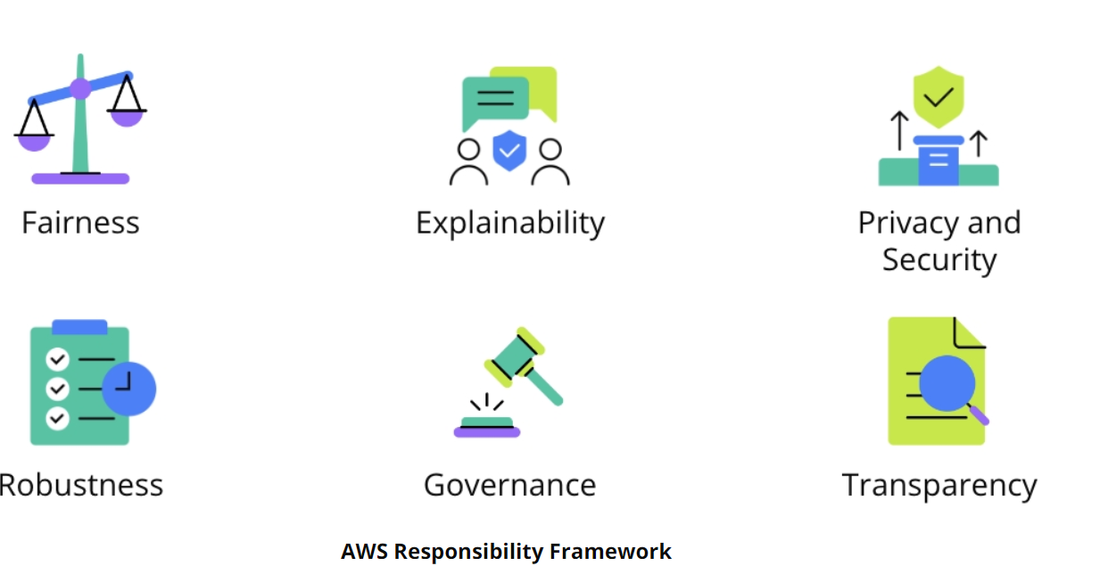

### **Operationalizing Ethical AI Principles**

* **AWS's AI Service Cards and Platform Tools** - These resources offer transparency on AI capabilities and limitations, assist in detecting biases, and enhance the understanding of AI decisions.
* **Education and Training** - Organizations must invest in training their workforce, from engineers to decision-makers, in responsible AI practices, including AI ethics and technical skills for developing inclusive AI systems.

### **The Commitment to Responsible AI Development**

Responsible and inclusive AI development is an ongoing journey that demands adherence to ethical frameworks and a dedication to diversity.

By embedding ethical values and inclusivity in AI research and development, the tech community can maximize the potential of generative AI while mitigating its risks, ensuring it serves as a beneficial force that reflects and respects the diversity of human experiences.

# SageMaker Model Cards

## **Model Cards**

A **model card** is a detailed document or report that provides critical information about a machine learning (ML)/AI model in a structured and accessible format. It's designed to offer transparency and governance for machine learning models, especially when they are deployed in real-world applications.

Key elements of a model card typically include:

1. **Model Overview** - a general description of the model, its purpose, the problem it's intended to solve, and the algorithm type it employs.
2. **Intended Use** - outlines the specific scenarios and applications for which the model is designed. It also mentions scenarios where the model should not be used, thus guiding responsible deployment and use.
3. **Risk Ratings** - the model is categorized based on the level of risk associated with its application, which can range from low to high. This helps in understanding the potential implications of the model's predictions and decisions.
4. **Training and Evaluation Details** - information about how the model was trained, the data it was trained on, the training environment, and the metrics used to evaluate its performance.
5. **Model Performance and Metrics** - specific performance metrics, observations from evaluations, and any relevant graphs or statistical data are documented here.
6. **Ethical Considerations and Recommendations** - any ethical concerns related to the model and recommendations for its use, including any limitations or biases that users should be aware of.
7. **Versioning** - model cards maintain a record of changes made to the model, ensuring that there is a transparent history of its development and modifications.
8. **Additional Information** - custom details, caveats, and any other relevant information that doesn't fit into the standard sections can be included here.

Model cards in Amazon SageMaker follow a JSON schema to standardize the format and make it easier to create, share, and update these documents.

# **Compare Model Cards**

## **Understanding Model Cards**

In this exercise, you will be working with two hypothetical model cards derived from the Amazon SageMaker Model Cards framework. These model cards are essential tools for documenting the key aspects of machine learning models, offering insights into their design, use, limitations, and governance. The model cards you will review are:

1. **Patient Readmission Prediction Model** - designed to predict the likelihood of patients being readmitted to a hospital within 30 days of their discharge. It's a crucial tool in healthcare management, aiming to optimize patient care and resource allocation. The model uses patient data, historical trends, and various health indicators to make its predictions.
2. **Patient Treatment Outcome Prediction Model** - predicts the outcomes of different treatments for patients. It plays a significant role in assisting healthcare providers in making informed decisions about patient care plans. The model analyzes various factors, including patient health records, treatment history, and response to previous treatments, to predict the effectiveness of proposed medical interventions.

Both models operate in the sensitive and high-stakes domain of healthcare, making their accuracy, ethical considerations, and bias mitigation strategies critical.

Your task will be to review, understand, and compare these model cards, focusing on how they address these crucial aspects.

This exercise will help you develop a nuanced understanding of the role of model cards in ensuring responsible AI deployment, especially in critical sectors like healthcare.

### **Part 1: Review Each Model Card**

Read through both model cards thoroughly. Pay attention to details about model purpose, intended use, risk ratings, training, and ethical considerations.

### **Part 2: Respond to Multiple Choice Questions**

* For Model Card 1: Patient Readmission Prediction Model
* For Model Card 2: Patient Treatment Outcome Prediction Model

### **Part 3: Comparative Multiple Choice Question**

### **Model Card 1: Patient Readmission Prediction Model**

{

  "model\_overview": {

    "model\_description": "This model predicts the likelihood of a patient being readmitted to a hospital within 30 days of discharge.",

    "model\_owner": "XYZ Hospital Data Science Team",

    "model\_creator": "ABC University Healthcare AI Lab",

    "problem\_type": "Binary Classification",

    "algorithm\_type": "Random Forest",

    "model\_id": "PRP-2023-XYZ",

    "model\_artifact": ["URL to model artifact"],

    "model\_name": "Patient Readmission Predictor",

    "model\_version": 1.0,

    "inference\_environment": {

      "container\_image": ["SageMaker inference image uri"]

    }

  },

  "model\_package\_details": {

    "model\_package\_description": "A package for predicting patient readmission rates in hospitals.",

    "model\_package\_arn": "arn:aws:sagemaker:example",

    "created\_by": {

      "user\_profile\_name": "Data Scientist"

    },

    "model\_package\_status": "Completed",

    "model\_approval\_status": "Approved",

    "approval\_description": "Reviewed and approved for hospital readmission prediction.",

    "model\_package\_group\_name": "PatientCareModels",

    "model\_package\_name": "PatientReadmissionModelPackage",

    "model\_package\_version": 1,

    "domain": "Healthcare",

    "task": "Readmission Prediction"

  },

  "intended\_uses": {

    "purpose\_of\_model": "To assist healthcare providers in identifying patients at high risk of readmission.",

    "intended\_uses": "Predicting 30-day readmission risk; assisting in post-discharge planning.",

    "factors\_affecting\_model\_efficiency": "Quality of patient data, accuracy of historical records.",

    "risk\_rating": "Medium",

    "explanations\_for\_risk\_rating": "Erroneous predictions could impact patient care decisions."

  },

  "business\_details": {

    "business\_problem": "High patient readmission rates in hospitals.",

    "business\_stakeholders": "Healthcare providers, hospital management.",

    "line\_of\_business": "Healthcare Services"

  },

  "training\_details": {

    "objective\_function": "Minimize false negatives and false positives.",

    "training\_observations": "Trained on a dataset of 10,000 patient records.",

    "training\_job\_details": {

      "training\_arn": "arn:aws:sagemaker:example:training",

      "training\_datasets": ["S3 path to training dataset"],

      "training\_environment": {

        "container\_image": ["SageMaker training image uri"]

      },

      "training\_metrics": [{

        "name": "Accuracy",

        "value": 85

      }]

    }

  },

  "evaluation\_details": [

    {

      "name": "ModelEvaluation",

      "evaluation\_observation": "The model showed an accuracy of 85% in predicting patient readmission.",

      "evaluation\_job\_arn": "arn:aws:sagemaker:example:evaluation",

      "datasets": ["S3 path to evaluation dataset"],

      "metadata": {

        "Additional Notes": "Evaluated on a separate test dataset of 2,000 records."

      }

    }

  ],

  "additional\_information": {

    "ethical\_considerations": "The model should not be the sole decision-making tool in patient care.",

    "caveats\_and\_recommendations": "Recommend further validation and regular updates with new patient data."

  }

}

### **Model Card 2: Patient Treatment Outcome Prediction Model**

{

  "model\_overview": {

    "model\_description": "This model predicts patient treatment outcomes based on medical history, demographic data, and treatment details.",

    "model\_owner": "XYZ Hospital Data Science Team",

    "model\_creator": "DEF Medical Research Lab",

    "problem\_type": "Multiclass Classification",

    "algorithm\_type": "Deep Neural Network",

    "model\_id": "PTOP-2023-XYZ",

    "model\_artifact": ["URL to model artifact"],

    "model\_name": "Patient Treatment Outcome Predictor",

    "model\_version": 1.2,

    "inference\_environment": {

      "container\_image": ["SageMaker inference image uri"]

    }

  },

  "model\_package\_details": {

    "model\_package\_description": "A model package for predicting outcomes of various treatments in patients.",

    "model\_package\_arn": "arn:aws:sagemaker:example",

    "created\_by": {

      "user\_profile\_name": "Data Scientist"

    },

    "model\_package\_status": "InProgress",

    "model\_approval\_status": "PendingManualApproval",

    "approval\_description": "Under review for ethical and bias considerations.",

    "model\_package\_group\_name": "TreatmentOutcomeModels",

    "model\_package\_name": "PatientOutcomeModelPackage",

    "model\_package\_version": 1.2,

    "domain": "Healthcare",

    "task": "Treatment Outcome Prediction"

  },

  "intended\_uses": {

    "purpose\_of\_model": "To predict patient outcomes for different treatments to aid in personalized medicine.",

    "intended\_uses": "Predicting treatment effectiveness; aiding in treatment personalization.",

    "factors\_affecting\_model\_efficiency": "Quality of data, diversity of patient demographic in training dataset.",

    "risk\_rating": "High",

    "explanations\_for\_risk\_rating": "Potential for bias in treatment predictions based on demographic data."

  },

  "business\_details": {

    "business\_problem": "Need for personalized treatment plans to improve patient outcomes.",

    "business\_stakeholders": "Healthcare providers, patients, insurance companies.",

    "line\_of\_business": "Personalized Medicine"

  },

  "training\_details": {

    "objective\_function": "Maximize accuracy while ensuring fairness across demographics.",

    "training\_observations": "Trained on a diverse dataset, but potential underrepresentation of certain groups.",

    "training\_job\_details": {

      "training\_arn": "arn:aws:sagemaker:example:training",

      "training\_datasets": ["S3 path to training dataset"],

      "training\_environment": {

        "container\_image": ["SageMaker training image uri"]

      },

      "training\_metrics": [{

        "name": "Accuracy",

        "value": 80

      }]

    }

  },

  "evaluation\_details": [

    {

      "name": "ModelEvaluation",

      "evaluation\_observation": "The model shows biases in predictions for certain demographic groups.",

      "evaluation\_job\_arn": "arn:aws:sagemaker:example:evaluation",

      "datasets": ["S3 path to evaluation dataset"],

      "metadata": {

        "Additional Notes": "Requires further analysis for bias mitigation."

      }

    }

  ],

  "additional\_information": {

    "ethical\_considerations": "High risk of biased outcomes affecting certain patient groups. Requires careful monitoring and regular updates for bias mitigation.",

    "caveats\_and\_recommendations": "Use with caution. Regular audits and updates recommended to address potential biases."

  }

}

Understanding and mitigating biases, along with continuous education and collaboration, are key to responsible AI use.

1. **Ethical Frameworks** - Essential for aligning AI development with societal values, emphasizing transparency, accountability, fairness, and privacy.
2. **Generative AI's Impact** - AI's role in content creation and decision-making necessitates ethical considerations to prevent misuse.
3. **Mitigating Bias** - Inclusive and diverse training data, coupled with continuous testing, are crucial to reduce biases in AI systems.
4. **Inclusivity in Development** - Diverse teams and stakeholder involvement are vital for identifying and addressing ethical concerns in AI applications.
5. **Operationalizing Ethics** - Tools like AWS's AI service cards help provide transparency and facilitate bias detection in AI models.
6. **Educational Commitment** - Continuous learning and training in AI ethics and technical skills are necessary for responsible AI development.
7. **Collaborative Approach** - Collaboration between developers, users, and policymakers is key to democratizing AI and ensuring it serves diverse global needs.

# Project Overview

## **Project Introduction**

Imagine you are an AI engineer. Your team is exploring innovative ways to enhance customer experience and streamline information delivery. You've been entrusted by your boss to develop a proof of concept (POC) for a domain expert model. This model will be trained on a dataset of domain-specific knowledge (finance, medical, or IT domain knowledge). The model can then be used to create chat applications, internal knowledge applications, or text content generation for company collateral.

**Project Objective**

Your task in this project is to train (fine-tune) a large language model. This model should become a domain expert, capable of generating informative, accurate, and contextually relevant text responses. Think of it as creating a knowledgeable consultant for the company!

**The Challenge**

Selecting the Dataset: Choose an appropriate, copyright-free unstructured text dataset relevant to a domain. You'll choose from finance, medical, or IT datasets. This dataset will be the training ground for your model to learn domain-specific language and concepts.

**Overview of Project Tasks**

* Fine-tuning the Language Model:
  + Utilize Amazon Sagemaker and other AWS tools to fine-tune the Meta Llama 2 7B foundation model. This model has been trained for text-generation tasks. The goal is to adapt this model to your selected domain, enhancing its ability to understand and generate domain-specific text.

**Deliverables**

* Trained Model: A fine-tuned language model proficient in your chosen domain.
* Report and Presentation: Documentation of your process, challenges, and solution.

**What You Will Learn**

* Advanced skills in machine learning and natural language processing.
* Hands-on experience with AWS tools like Amazon Sagemaker.
* Insights into domain-specific language model training.
* Practical application of AI in solving real-world business challenges.

On the following pages, you'll find detailed instructions on project steps, environment configuration, and resources, and directions for completing and filling out deliverables.

You'll submit your project and it will be assessed by a project reviewer against this [**rubric(opens in a new tab)**](https://review.udacity.com/#!/rubrics/5366/view). Take a moment to read through this [**rubric(opens in a new tab)**](https://review.udacity.com/#!/rubrics/5366/view) to familiarize yourself with the key deliverables for the project and what the reviewers will be looking for in your submission.

## **Project Summary**

1. Configure your AWS Sagemaker resources
2. Using Python and the Sagemaker API:
   1. Deploy the Meta Llama 2 7B foundation model on the AWS platform
   2. Test and evaluate the model for its responses to domain knowledge and text-generation tasks
   3. Fine-tune the model on your chosen dataset
   4. Deploy the fine-tuned model
   5. Test the fine-tuned model on domain-specific knowledge and text generation tasks relevant to your dataset.
3. Document and submit!

# AWS Sign In and Costs

## **Launch the AWS Web Console**

In this course, Udacity offers you a federated user account, a temporary AWS user account with limited permissions. We call it a Cloud Lab. You can use the Cloud Lab for educational purposes only.

Before you begin, be sure to log out of any AWS instances you may already have running. Then click the **Launch Cloud Gateway** link in the bottom left navigation pane to access the Cloud Lab. Clicking on the button will open up a pop-up, and clicking on the **Open Cloud Console** button in the pop-up will open the AWS console in a new browser tab. This may take a few moments to load the first time. See a brief video below for a walkthrough.

As you are given a temporary AWS user account with **limited** permissions, you might not be able to avail **all** AWS services. We have allowed the necessary ones only. If you see a few warning messages related to insufficient permissions, you can ignore them and proceed with your practice.

### **Important Points to Remember**

#### 1. Session Limit

Note that there is a certain session time limit. If reached, you will automatically be timed out. As long as you have not used your entire allocated budget, your work will be saved. You can re-launch using the same "Launch Cloud Gateway" button in the left navigation menu to return to your session.

#### 2. Default AWS Region

The default AWS region for you will be US East (N. Virginia) (us-east-1 ). In case you need more than one region for your work you can use us-east-2, us-west-1 or us-west-2. Note: You would not have permissions to access regions other than us-east-1, us-east-2, us-west-1, and us-west-2.

#### 3. Budget

All AWS services are a pay-as-you-go service. Udacity has set a budget for each student to complete their course work. Please understand that these credits are limited and available for you to use judiciously. The budget for this entire course is **$25**. Although, we find about $10 sufficient for most to complete this course.

If you hit your budget, your session will time out and your work will be lost and unrecoverable.

#### 4. No Extra Credits

We recommend you shut down/delete every AWS resource (e.g., EC2, Sagemaker, Database, EMR, CloudFormation) immediately after the usage or if you are stepping away for a few hours. Otherwise, you will run out of your allocated budget.

Udacity will not provide additional credits. In case you exhaust your credits:

* You will lose your progress on the AWS console.
* You will have to use your personal AWS account to finish the remaining ND.

Specifically, any service available to you @$0.1/hour or higher should be monitored closely and shut down immediately after use or if you are stepping away. Otherwise, most likely you will exhaust your credits before finishing the course.

To better understand pricing, see the [**AWS Pricing(opens in a new tab)**](https://aws.amazon.com/pricing/) for all available services.

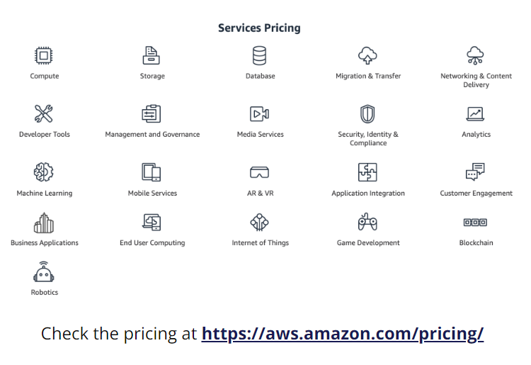

#### 5. Track your Usage

You need to make sure that you have an adequate budget available to complete your project/task. You can track your usage on the AWS web console, navigate to **Billing and Cost Management** > **AWS Cost Explorer**, and view the spending by selecting a date range. The starting date should be your date of enrollment in this course or program.

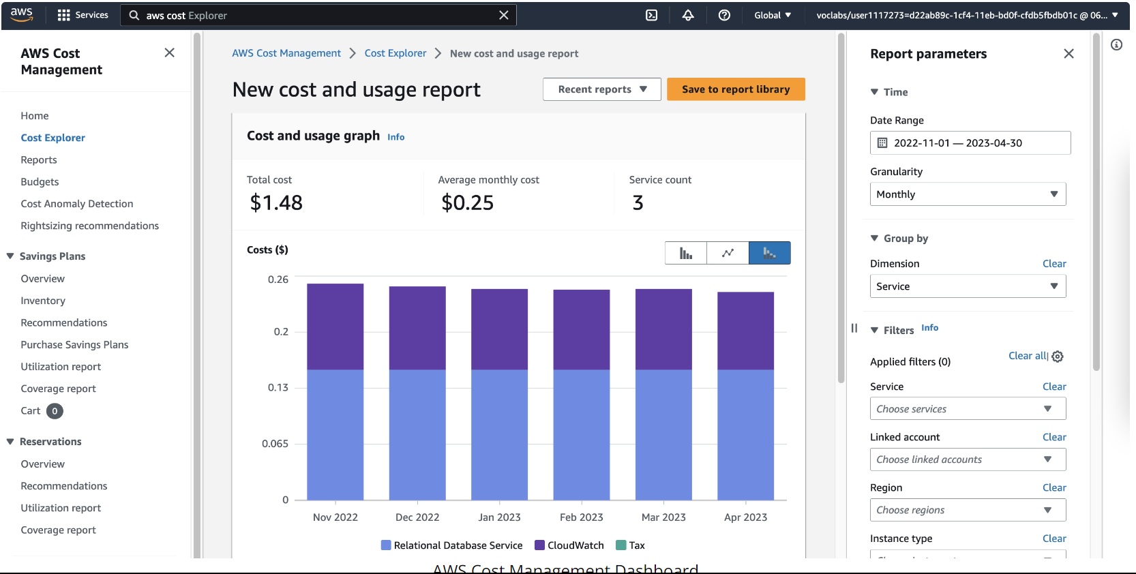

You can view the **AWS Cost Explorer** dashboard. However, we have disabled the **Billing** dashboard for security and privacy reasons.

#### 6. IMPORTANT

* **Concurrent/Parallel instance launch**: We do not support launching multiple EC2, RDS, or Sagemaker instances unless specifically mentioned in the classroom. Your AWS account will be suspended if you attempt at launching concurrent instances where they not required.
* **Personal Information in AWS**: Do not add any type of personal information to the AWS account and resources provided by Udacity for this course. This includes: email addresses, resource names, tags, phone number, name, etc.
* **Deleting and Reusing Accounts**: Udacity will delete all resources in AWS accounts after six months of inactivity to ensure proper resource utilization and data security. Deleting resources means that all work will be lost and will need to be redone.

# **Environment and Project Setup**

## **Configuring Your Project Environment**

Follow these steps to configure these required resources on the AWS platform.

1. An AWS SageMaker IAM Role
2. An AWS SageMaker Notebook Instance
3. A GPU instance for fine-tuning training
4. Download the [**project starter files(opens in a new tab)**](https://video.udacity-data.com/topher/2024/February/65bb2743_genaiwithawsprojectstarter/genaiwithawsprojectstarter.zip)

You can start and stop the SageMaker Notebook Instance and your Jupyter Notebook Python files will be saved. **Remember to stop your notebook instance when you are not using it.**

**Ensure you are always working in the US-west-2 Region by checking and changing the region in the dropdown menu in the top of the AWS console to US West Oregon (us-west-2)**

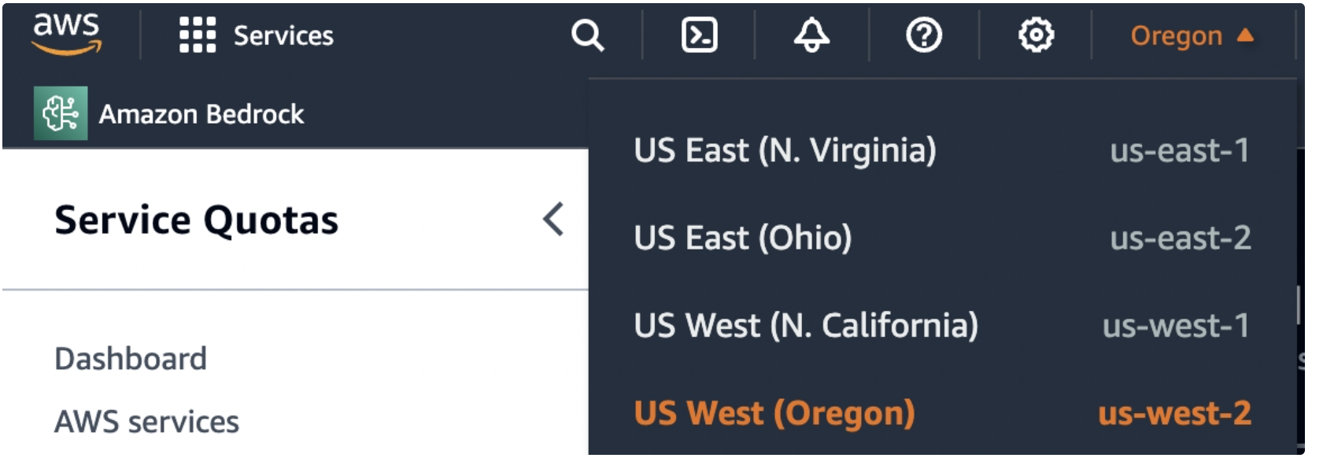

#### Configuring an IAM Role for AWS SageMaker

The first step is to make an IAM role you'll use throughout the project. This role will have all of the necessary permissions to run your Jupyter Notebook files, access AWS S3 Storage Buckets containing datasets, model deployment, and training jobs.

1. Log into the AWS console using the "Launch Cloud Gateway" button in the course menu. Navigate to the **[Sagemaker home page(opens in a new tab)](https://us-east-2.console.aws.amazon.com/sagemaker/home?region=us-east-2" \l "/landing" \t "_blank)**.
2. In the left navigation menu, choose Role manager, and click on "Create a role"

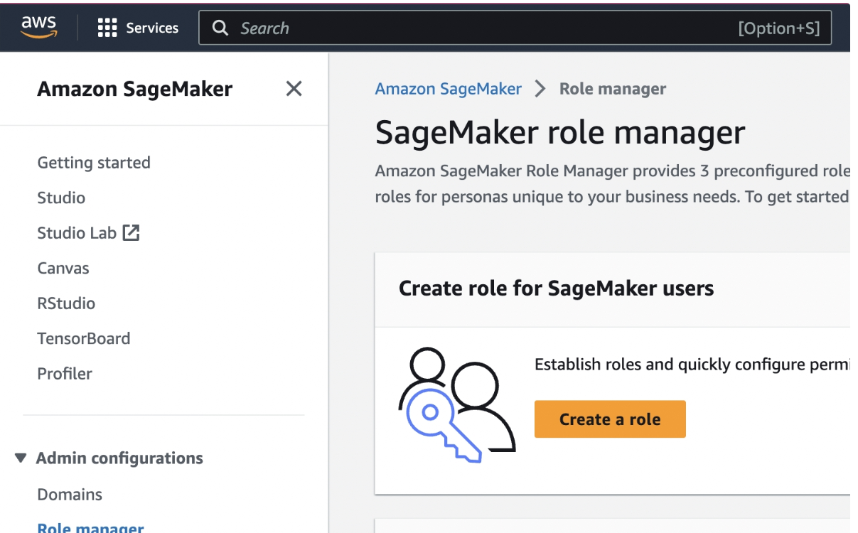

1. Name the Sagemaker role udacitySagemakerRole so you can identify it later. Configure the role with the following settings:

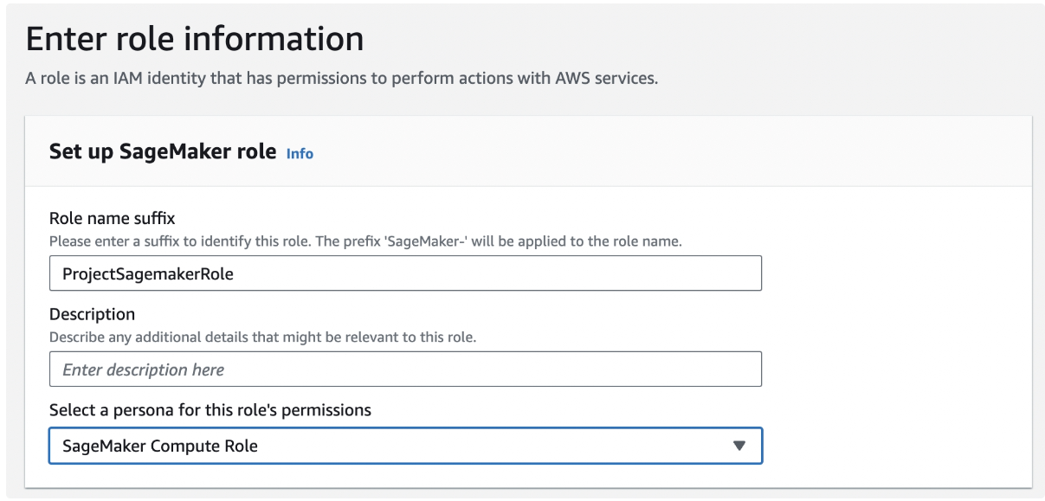

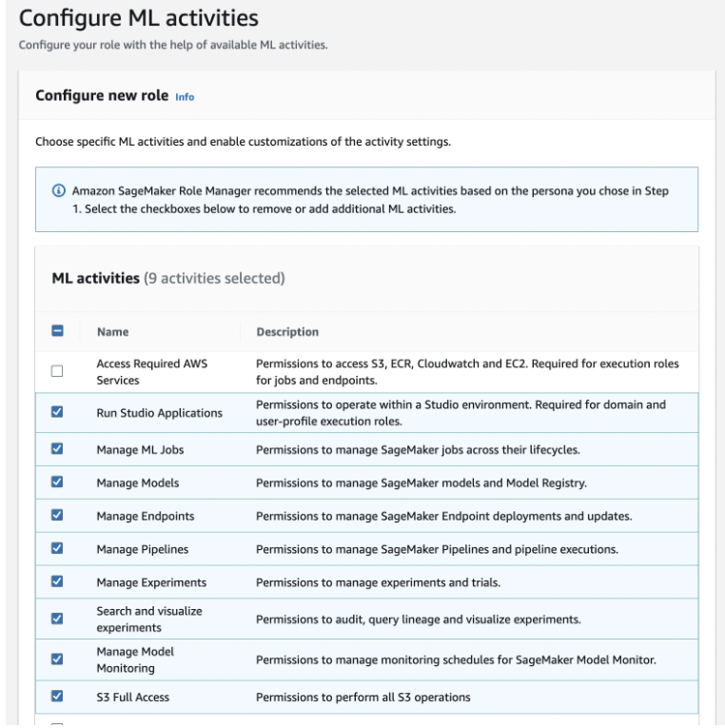

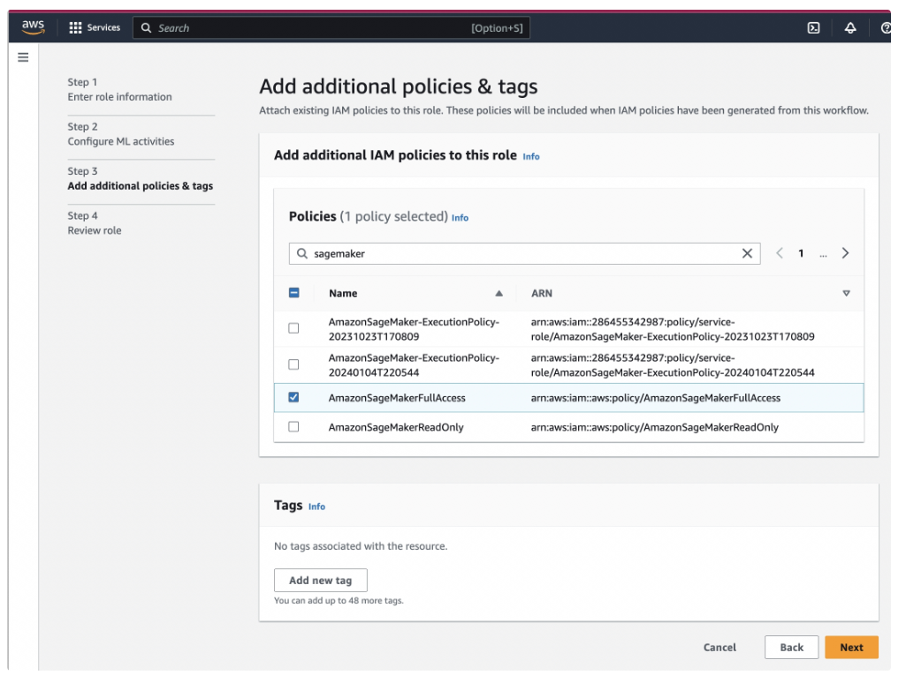

Validate the permissions in your role against these values to ensure you have assigned all the necessary permissions to complete the project.

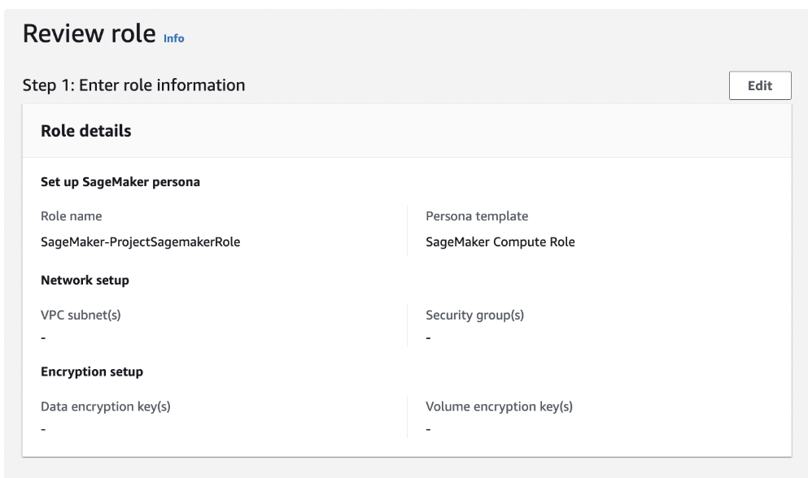

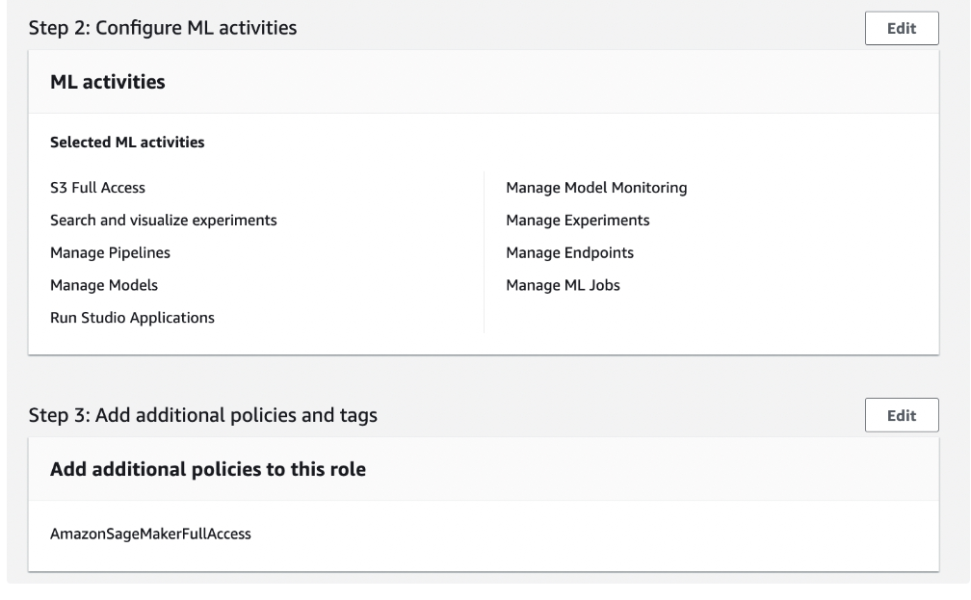

#### Creating an AWS SageMaker Notebook Instance

The next step is to create an AWS SageMaker Notebook Instance you'll use throughout the project. You'll create the Python Jupyter notebook files for the project in this instance. You'll use the IAM role you created in step 1 for this notebook instance.

An Amazon SageMaker Notebook instance is a EC2 virtual machine with the open-source Jupyter server installed The virtual machine costs money every hour it is running. **Make sure you stop your notebook instance to stop the virtual machine when you're not using it so you don't run out of budget**

1. In the AWS console, navigate to the Sagemaker home page, and choose **Notebook -> Notebook instances** from the left navigation menu
2. Click on "Create notebook instance" from the top of the page
3. Name your notebook instance and **ensure you choose the IAM Sagemaker role you created in Step 1 above.**

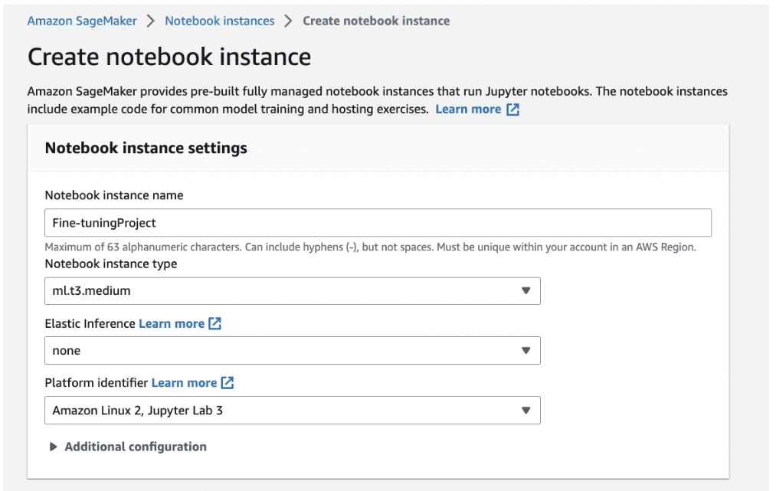

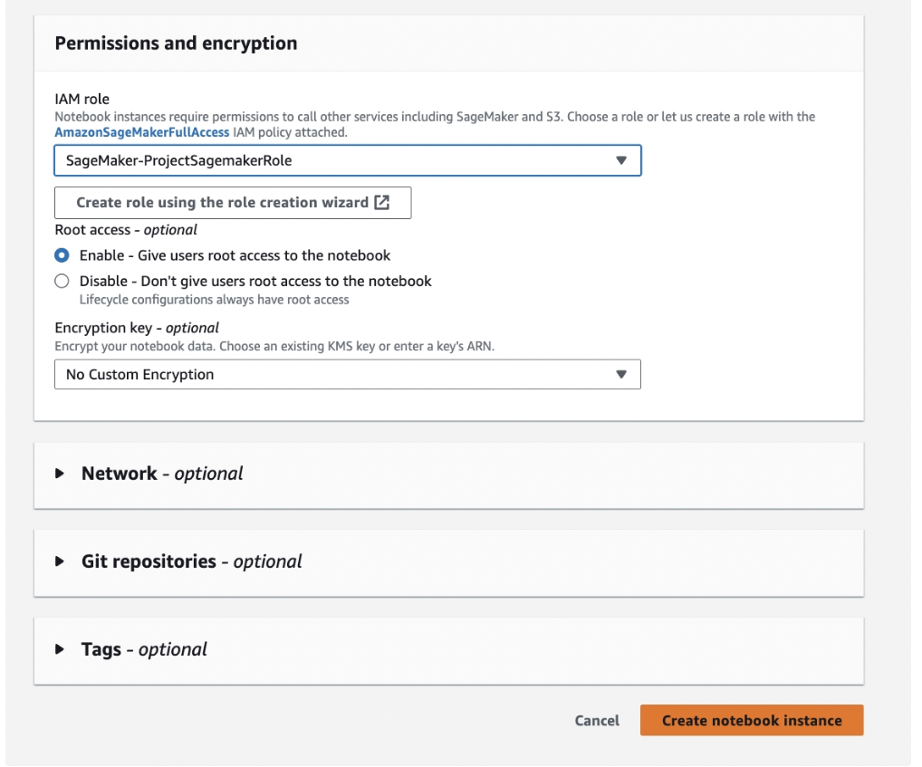

#### Request a GPU Instance for Training

You'll need to use an EC2 instance with a GPU to fine-tune the Meta Llama 2 7B model. Follow these instructions to visit the AWS Service Quotas dashboard and request a **ml.g5.2xlarge** instance for training job usage.

1. Visit the [**AWS Service Quota Dashboard(opens in a new tab)**](https://us-east-1.console.aws.amazon.com/servicequotas/home/)
2. In the AWS Services dropdown menu at the top of the page, choose or type Sagemaker, then click "View quotas" In the "Search by quota name" search box, enter **ml.g5.2xlarge.**
3. Locate the row that says **ml.g5.2xlarge for training job usage**, and fill in the circle next to it.
4. Click on the "Request increase at account-level" button at the top of the page, and enter 1 instances in the request form.
5. Submit the request

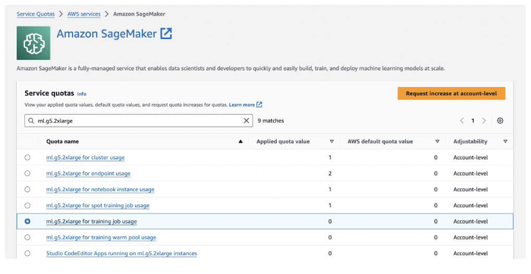

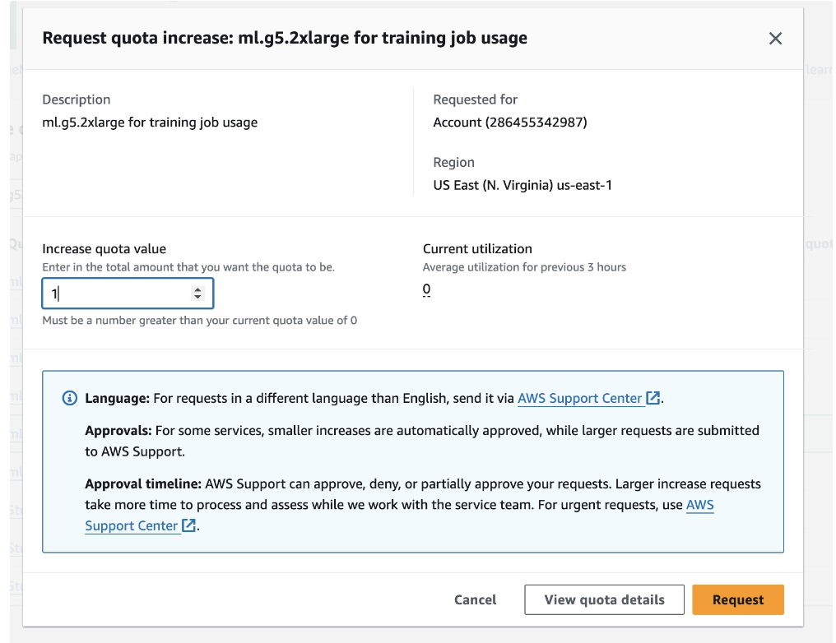

Verify your request was approved by visiting the [**Quota request history page(opens in a new tab)**](https://us-west-2.console.aws.amazon.com/servicequotas/home/requests)



# **Instructions**

## **Project Instructions**

#### Step 1: Upload Project Starter Files

Start your SageMaker Notebook Instance by clicking on **Open JupyterLab** once your notebook instance is ready.

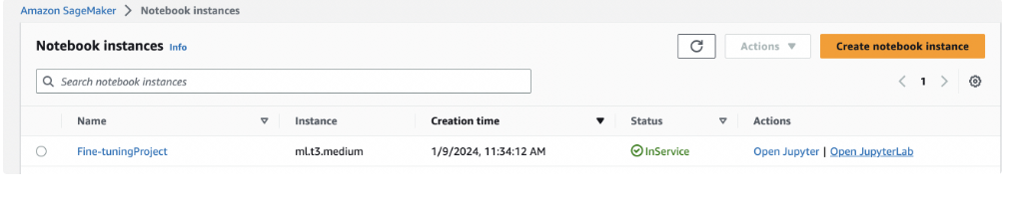

Upload the 2 Python notebook files (.ipynb) in the [**project starter files(opens in a new tab)**](https://video.udacity-data.com/topher/2024/January/65baa406_genaiwithawsprojectstarter/genaiwithawsprojectstarter.zip) folder to JupyterLab using the upload arrow in the top left menu.

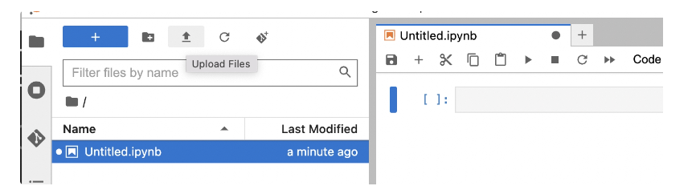

You should see two Jupyter Notebook files in the Jupyterlab file menu. Use the Python 3.10 Pytorch or Tensorflow Kernel to run code in these notebooks.

* **Remember to stop your notebook instance when you stop or pause work on your project.**
* **Make sure to save your individual notebook files periodically in JupyterLab using the File -> Save menu, otherwise your work will be lost between your classroom Cloud Gateway sessions.**
* ***If you don't see your notebook instance when logging back in, make sure your region is set to us-west-2***

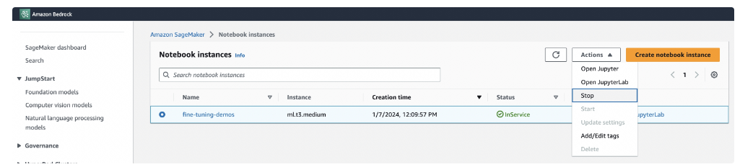

#### Step 2: Choose your Dataset

In the project notebook files, you'll have to make a choice of what type of domain expert you'd like your model to be. Your choices are:

1. Financial domain
2. IT domain
3. Healthcare/Medical domain

Fill out the domain you've selected in the Project Documentation Report

#### Step 3: Deploy and Evaluate the model

1. Complete and run the cells in the Model\_Evaluation.ipynb file
2. Take a screenshot of the Model\_Evaluation.ipynb file with the cell output as proof you completed this step of the project
3. Save and download your Model\_Evaluation.ipynb with the cell output, you'll be submitting this file.
4. **Double check you've ran the cells that delete the model deployment and endpoint. Verify your model and endpoint have been deleted. If you do not delete these, you will run out of budget and will be unable to complete the next part of the project.**
5. Fill out the Project Documentation section about your evaluation of the model's text generation capabilities and knowledge.

#### Step 4: Fine-tune the Model

1. Complete and run the cells in the Model\_FineTuning.ipynb file
2. Download your Model\_FineTuning.ipynb with the cell output, you'll be submitting this file.
3. Take a screenshot of the Model\_FineTuning.ipynb file with the cell output as proof you completed this step of the project
4. Fill out the Project Documentation Report section about fine-tuning the model.

#### Step 5: Deploy and Evaluate the Fine-tuned Model

1. Visit the AWS S3 bucket where your fine-tuned model weights are stored after training and take a screenshot for your submission.
2. Complete and run the cells in the Model\_FineTuning.ipynb file about deploying and evaluating the fine-tuned model
3. Take a screenshot of the Model\_FineTuning.ipynb file with the cell output as proof you completed this step of the project
4. **Double check you've ran the cells that delete the model deployment and endpoint. Verify your model and endpoint have been deleted. If you do not delete these, you will run out of budget and will be unable to complete the project.**
5. Fill out the Project Documentation Report section about your evaluation of the **fine-tuned** model's text generation capabilities and knowledge.

#### Step 6: Collect Project Documentation and Submit

1. Revisit the project assessment [**rubric(opens in a new tab)**](https://review.udacity.com/#!/rubrics/5366/view) and verify you've completed all of the project requirements and have collected all of the necessary files, proof, and documentation you need to submit the project
   * Model\_evaluation.ipynb with cell output
   * Model\_FineTuning.ipynb will cell output
   * Screenshots of both notebooks with cell output
   * The completed Project Documentation Report

## **Submission Instructions**

Place all of your project files in one folder and zip the folder.

Follow the submission instructions on the next page to upload your zipped folder containing your project.

## **Instructions Summary**

* Complete the project steps above
* Collect all supporting project files and screenshots
* Fill out the documentation file
* Check the [**rubric(opens in a new tab)**](https://review.udacity.com/#!/rubrics/5366/view) to ensure you've completed all of the requirements
* Zip up your project files in one folder for submission

# Rubric Evaluation

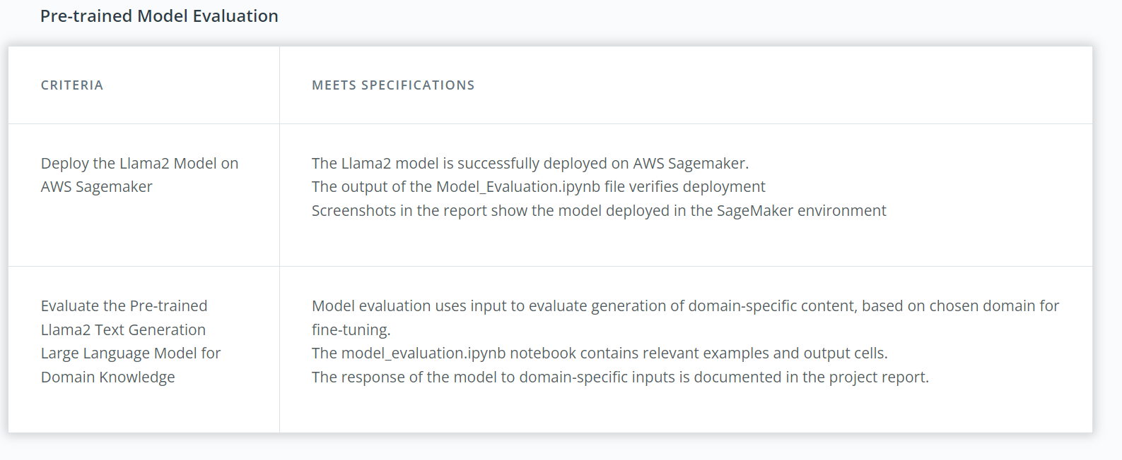

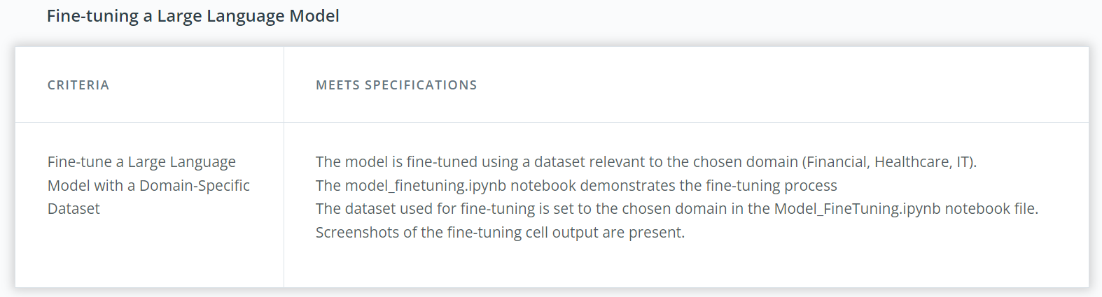

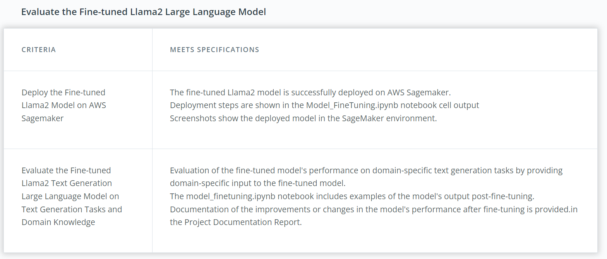

# Output

**Generative AI with AWS**

**Project Documentation Report**

|  |  |
| --- | --- |
| Question | Your answer: |
| **Step 2: Domain Choice**  What domain did you choose to fine-tune the Meta Llama 2 7B model on?  Choices:   1. Financial 2. Healthcare 3. IT | IT  **Question** A second important aspect of ubiquitous computing environments is |
| **Step 3: Model Evaluation Section**  What was the response of the model to your domain-specific input in the **model\_evaluation.ipynb file**? | A second important aspect of ubiquitous computing environments is  > the notion of context. Context is a term that has been used in the literature for a long time, but its meaning has been quite elusive. Context refers to the information about the user and his or her surroundings that is used to adapt the behavior of the system to the user's preferences and |
| **Step 4: Fine-Tuning Section**  After fine-tuning the model, what was the response of the model to your domain-specific input in the **model\_finetuning.ipynb file**? | A second important aspect of ubiquitous computing environments is  'generation' |